SFB 2010-2011 Name

Take your time; you get all the time you need. Read the questions well. If questions seem very simple, they probably are. Use common sense. Write legible; it is easy for Gert and Geerten to oversee an error when the answer is written clearly and legibly. Keep the answers short (!) so think before you write. You can answer in Dutch, English, or Hochdeutsch. The amount of white space is all you get to answer. Don't use more space; shorter answers are always better (and take less time to grade). All questions are worth equally many points. If everybody writes clear and legible I promise that I will have my part graded by Monday!

1) a) Which peptide is this in 1 and 3 letter code? (the atom that is hidden in the shade is red).
b) The peptide is drawn as a β-strand. But obviously it is not a very nice β-strand. You are allowed to make 4 sequence changes to make it a much better β-strand. Write your new sequence neatly and well-aligned underneath the native sequence.
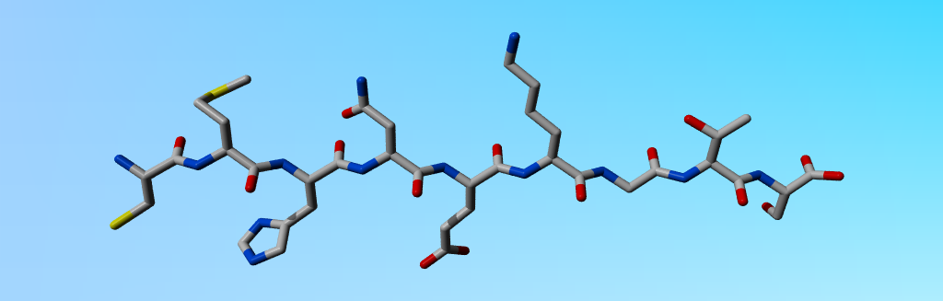
CMHNEKGTS
CMHVEI
To make it a strand, put in VITWYF, remove PSDNG, and make it alternating foob-fiel. Many sequences are OK once those three things are kept in mind.

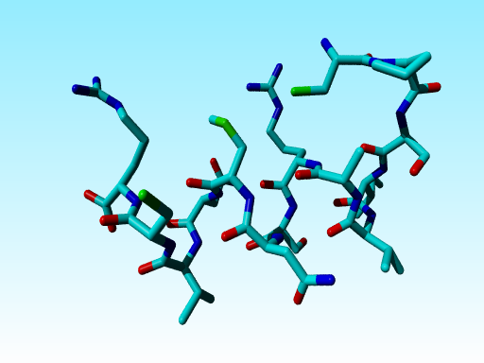

2) Find and circle the wrong amino acid in this figure. (With ‘wrong’ I mean that it doesn’t occur in your body.
You may assume that things that are difficult to see are correct.
The wrong one is the Cys-like thing in the middle (it is either a Cys with a Cδ on it, or a Met with a carbon missing.

4) a) What is all special about cysteine? b) What is all special about tryptophan? c) And why is such knowledge important for sequence alignments?
Next year I will again try to make the questions more clear. The things that are special about Cys (bridges, reactive, active site, metal binding) and Trp (biggest and very hydrophobic and rigid, and thus most conserved) you can look up, but with "And why is such knowledge important for sequence alignments?" I had hoped that people would come with things like "such knowledge helps you understand exceptions in alignments, helps you solve alignment problems in difficult areas, etc"
5) a) What is all special about proline? b) What is all special about histidine? c) And why is such knowledge important for protein engineering? Same problem as question 4. "And why is such knowledge important for protein engineering?" was generally misunderstood. In this case I had hoped that people would say things like "The fact that the proline has no polar H in its backbone means that you know at which locations in a β-strand you can(not) introduce a proline". Etc.

6) In July our troops will go to Libya to pick up a helicopter they forgot one day. Libya has many, many scorpions. So we need a vaccine against scorpion toxin for the poor soldiers who will go there trying to find this helicopter (that cost us just as much as 10.000 years of your tuition fee). Can you tell me how you would go about designing this vaccine? (and at the end explain to me why it will not work after all)? Especially mention all software used in the whole process, and what each piece of software does (or if you never used it yet, what it should do)?
This question was not done well in general. Especially the sentence in red was read by only a few of you. The steps are: Get the structure, or if needed the model. Run an antigenicity predictor (poke around at http://immunax.dfci.harvard.edu/Tools/antigenic.html or similar sites to find info; I obviously do not expect you to know this at the exam). Find nicely accessible somewhat stretched loops with good antigenicity scores. Synthesize one or a few peptides. Add adjuvant. Try it on a rabbit (so use peptide as vaccine, with or without boosters, I don't care). Now let scorpion sting rabbit. If rabbit still eats carrots the next morning, you can try it on humans (use a student as volunteer...). There are many rules for tests on humans, but that is merely a detail for the concept.
Obviously this won't work in practice because 1) there are thousands of scorpions so that a vaccine against the toxin of one of them won't work and 2) toxins work much faster than the body can make antibodies.

7) In the previous question you undoubtedly wrote something about force-field-based software that can predict the antigenicity of a peptide or protein. Such software exists already. But let’s assume for a few minutes that it didn’t exist yet, how would you design it? What data would you need? Which machine learning technique would you apply? How would you analyse the performance of your force field based software?
Simple. Collect data on antigenic peptides. Count the frequency of each residue type in those peptides. Count the amino acids in the non-antigenic parts of those proteins. The difference between the two frequencies (better take log of division) is a measure for their antigenicity. Convert this into a list of 20 antigenicity preferences. Now, score all peptides that are antigenic and all that are not (or better do this test on peptides that you did not use while making the FF), and that will undoubtedly give you two irregular Gaussian distributions. Decide on a cut-off (base this on your ideas about the numbers of false positives and false negatives you are willing to accept).

8) Given two sequences: a) DCAGWLPYTXGE and b) DCAGWLGHAARTSPAFGLREWPYTXGE. Both unfold at 53 °C. In both cases residue X was mutated to become a cysteine that bridges with the Cys already present at position 2 in the same sequence. After the mutations were made, one protein unfolded at 56 °C and one at 58 °C. Which of the two do you think became most stable? And why do you think that?
The longer the distance between the two Cys, the more they restrict the entropic chain freedom of the unfolded form and thus the less freedom is lost upon folding, the easier the protein folds, and the more stable it is.

9) Why do all good secondary structure prediction methods use multiple sequence alignments as input?
See the answer in the exam from a few years ago.

10) The protein listed below is found in the genome of the bacterium horrivus sujeirus. This peptide is the main reason why people can be very allergic to bytes of insects that carry this bacterium in their saliva.
TLSATWCSGLWILAMVLLAMILSLAMVVLAMTSLACGNAWTAQAGGKNRSKTLLLAILWYLSLLALIMLFFACWLLAINGDSD

The department of immunology of the Radboud hospital has made a nicely working system that makes very good antibodies against peptides of length 9 that have a tryptophan at position 5. Can you tell them which nona-peptide to use in this bacterium horrivus sujeirus protein to make antibodies that will reduce the suffering of the allergic people? And why do you suggest just that peptide and not any of the other possibilities?
The two red stretches are transmembrane helices. The blue R and K and the positive-in rule tell you that only the green fragments are extracellular. So the first W (bold) is the middle of the nona peptide LSATWCSG that we should try.

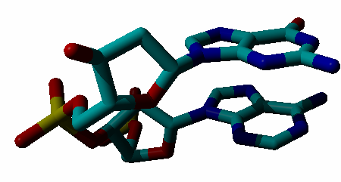
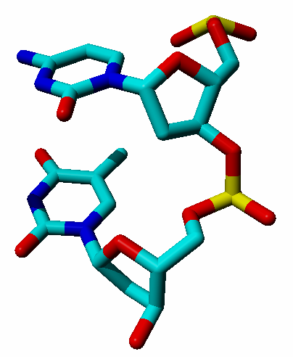
11) a) Label the four bases in this figure with their one letter code.
b) Is this DNA or RNA?
c) Who base-pairs with who?
You can look this up.

12) Why are active sites often
located at the bottom of a dent
in the enzyme’s surface?
Two main reasons are that 1) in such a case the protein can touch the ligand from many sides which allows it to better regulate the specificity and 2) the waters in the dent are unhappy waters and thus provide a lot of 'entropy of water' when they make place for the ligand.

13) a) Mention a few terms (formulas not really needed, but allowed) that are used in the force field of a molecular dynamics software package. b) And mention a few terms that generally are not yet in use in such a force field?

Used (albeit that not each term is used in each FF): bond lengths, bond angles, torsion angles, hydrogen bonds, electrostatic interactions, Van der Waals interactions.
Not used: induced polarity; quantum chemical things; three/four body interactions.

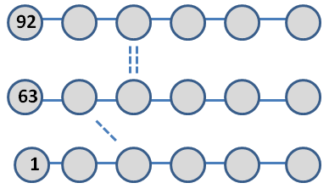
14) The picture to the right is a (very) schematic representation of a sheet that consists of 3 strands. Each circle represents an amino acid. The solid lines indicate which residues are adjacent in the sequence/structure. Three residues have been numbered, and three hydrogen bonds have been indicated by dashed lines.

a) Write the numbers of all residues in the gray circles.
b) Add the missing hydrogen bonds by drawing the (dashed) lines between the circles.
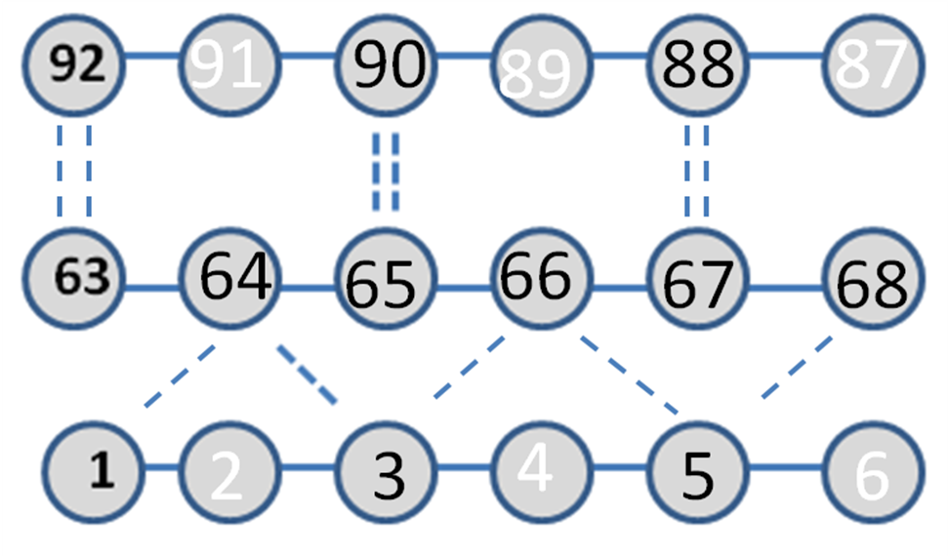
c) This small sheet contains 6 (yes, indeed, six...) prolines. Please circle them in the plot.

I started with 1. From there I could fill-ot till six without thinking. As the strands starting with 1 and with 63 are parallel (seen from the one tilted H-bond between 3 and 64), I can fill out 63-68. I actually could also have given residue number 92 and 87 and not the second H-bond. In both cases you would know that the middle and top strand are anti-parallel. Now you must put in the anti-parallel H-bonds using only those residues that don't make two H-bonds yet in the parallel sheet. Remember that each residue (except pro) has1 O and 1 H, and in strands and helices those make 1 H-bond each. The prlines can now be inserted at the white positions, because those do not make H-bonds and thus no H-bond would be lost by the NH proton that proline doesn't have.

15) Why do we find more A and T in promotor binding sites than C and G?
Only two H-bonds makes that AT is more easily bendable, openable, etc than GC, and at promotor binding sites 'something must happen' and 'something' usually is motion.

16) Mention four (different) roles for water in living cells.
The entropy of water drives everything
Water fills gaps in and between macromolecules
It is the solvent in which everything else swims around
It often is part of reactions (hydrolysis, etc)

17) I am looking at a short stretch of residues from the middle of a big protein. The residue at the top left has number 81, and the one near the bottom right has number 90. Can you please write the 10 residue numbers in or near the correct red island in the Ramachandran plot?
The top left island is for beta residues; bottom left for helix, and the tiny red island to the right is for the left handed helix (there is only one short left handed helix in the PDB, so the small red island is for funny turn residues. You need something ‘different’ between the strand that the thing begins with strand (that must be, because they are in a red island (three people did not read that, so I made it red in the question) and you can see that they cannot be helix, and you can know that they aren’t left-handed helix). It clearly ends with helix. And now you need one thing to bend from the strand into the helix. As you (sorry, the capslock isn't stuck but word does strange here on two different computers) need to place the residues near a red island, you need to put one or two residues near the left handed helix area. Those should be 83 and or 84.
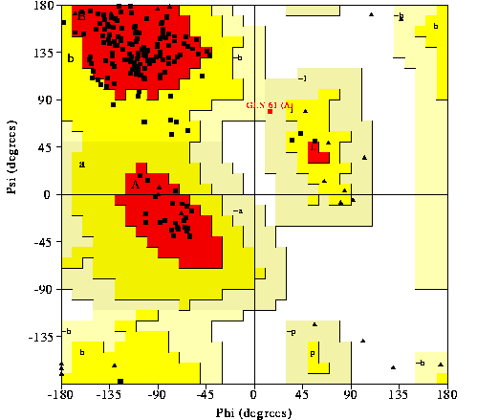
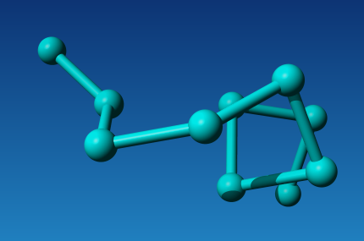

18) Mention many different ways to find-out which cysteines are bridged in a protein.

- Look it up in SwissProt
- Look it up in the PDB
- Look in homologs in SwissProt
- Look in homologs in the PDB
- Look for correlated mutations (i.e. if in a multiple sequence alignment two cysteines are always present together and always absent together)
- Find in the internet a web-server that predicts cys-cys bridges
- And finally, (Autsch, uffa, verdorie, darn,..) do an experiment

19) For a study on ions in proteins I started making pictures. unfortunately, I lost the list that tells me which ion is in which picture. I don't want to make all pictures again. Can you help me and find out which yellow ball is Calcium, which is Sodium, which is Vanadium, and which is Zinc?

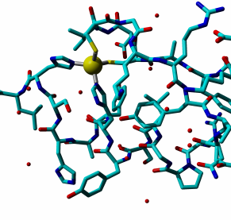
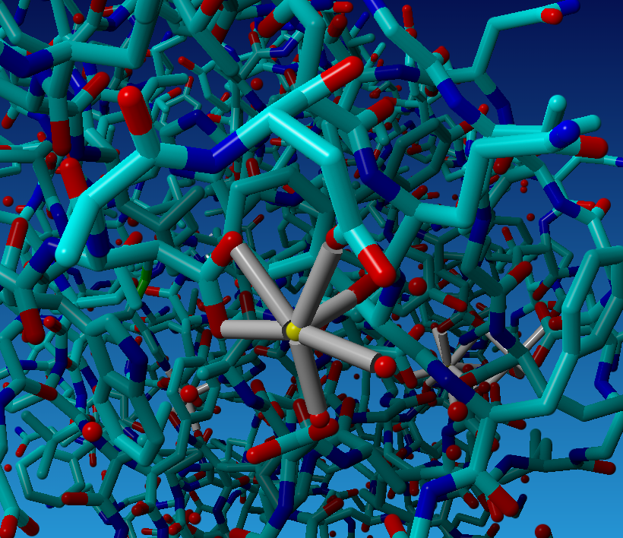
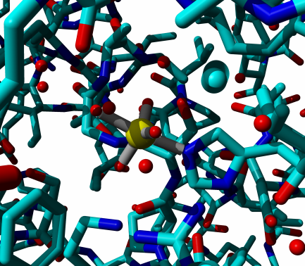
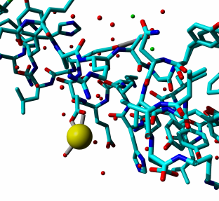
Calcium is 2+, Sodium is 1+, Zinc tends to be surrounded by N and S, and I have no idea about Vanadium. Top-right thus is Zinc (almost everybody got that one right). Bottom right is bound by one Asp (thus sodium), and top left by two Asp (and even a third one via-via) and is thus calcium. That leaves the complicated one bottom left that is bound by His, backbone-N, backbone-O and a few things I cannot see well no choice bu Vanadium.


20) During the course we often encountered so-called ‘kwik, kwek, and kwak’ questions. These were questions that seemed very complicated but weren’t and one would expect the boy-scouts handbook of these three famous Disney ducks to already hold the answer. I have listed here a series of such questions. Some of them are totally trivial, some might cost you 5 minutes of hard (but simple) computation. The whole question 20 is worth just as much as each of the other 19 questions (in other words, this question will take a lot of time and bring you only a few points).

a) Mary is on a diet because she want to use her wedding dress again at the day of the ten year celebration of her marriage. This celebration two weeks from now. But Mary got very weak and went to the vending machine (Dutch: snoep-automaat) to get some candy. She wants to take either 100 gram of very fatty fudge or 100 gram of double salt liquorice. What would you advise her to take (see also 20b)? And why?
Fudge holds more calories so that is generally worse. But double salt anything holds much salt and that makes that the body will retain water. So two weeks before the big day, take the salty stuff because it wears off easily in 14 days, but the day before, go for the fudge. 100 grams fudge is 100 grams in the body. 100 grams double salt anything will easily make the body retian a liter of water, and that is a kilo the next day...

b) Paula is on a diet because she want to use her wedding dress again at the day of the ten year celebration of her marriage. This celebration tomorrow. But Paula got very weak and went to the vending machine (Dutch: snoep-automaat) to get some candy. She wants to take either 100 gram of very fatty fudge or 100 gram of double salt liquorice. What would you advise her to take (see also 20a)? And why?

c) Earth-wide there live about 8 spiders per square foot. How many spiders live on earth? Work this out on the back of a page and only give the answer here. If you get within a factor of ten from the correct answer, I won’t look at the back of that page.
Many Kwik, Kwek, Kwak ways to calculate this. I choose: 4*pi*r^2 with r is a bit more than 6000 kM gives roughly 10*36000000. ¾-th is water and spiders don't swim well. So, 10*36million / 4 gives roughly 100 million square kilometers. A kilometer is 3000 foot. So there are 10⁸*3000²*8 spiders and that is (again Kwik, Kwek, and Kwak don't care about a factor 2) = 10⁸*10⁷*10=10¹⁶ spiders on earth. Now, let's hope you are not arachnophobic...Another calculation would be that each human has a bit more than 1 hectare available to him/her. In 20 years there will be 10¹⁰ people. 1 hectare is 3002 square foot. So Spiders=10¹⁰*300²*8 ~ 10¹⁰*10⁵*10=10¹⁶

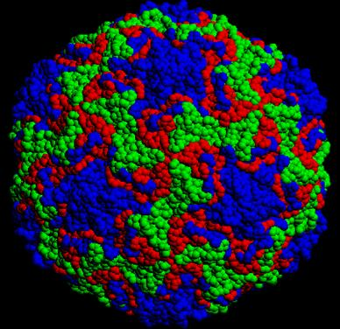
d) This is a very simple RNA virus. Viral coat proteins with an identical sequence are plotted in an identical colour. a) How many proteins are in its shell? 60 units are needed to close the icosahedron. so most likely (red+blue+green)*60 = 180
B) Besides these coat proteins, the viral RNA codes for two more proteins. Can you guess their functions? Something to tell the human to use and duplicate its RNA and something to cleave its coat protein after production into three separate chains.
c) The number of bases in the viral RNA starts with a 4. Can you tell me how many zeros should be written behind this 4? I guess 4000 bases is enough for 5 proteins. remember that viruses deal very, very efficiently with their genomic material.

e) I eat every day more than I shit. Still I am on a diet and lose weight every day, which seems to contradict the first statement. Can you solve this puzzle?
Food is mainly water that is taken care of by kidneys and lungs (water on the window of your bedroom after a night that was cold outside and warm inside left the body a little bit as sweat but mainly through the lungs). Further, I produce CO2 that also goes out through my lungs. A human produces almost a kilo of CO2 per day. So it doesn't seem unlikely that most food leaves body again through the lungs!

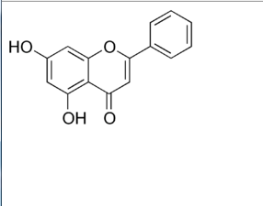
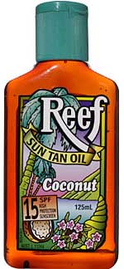
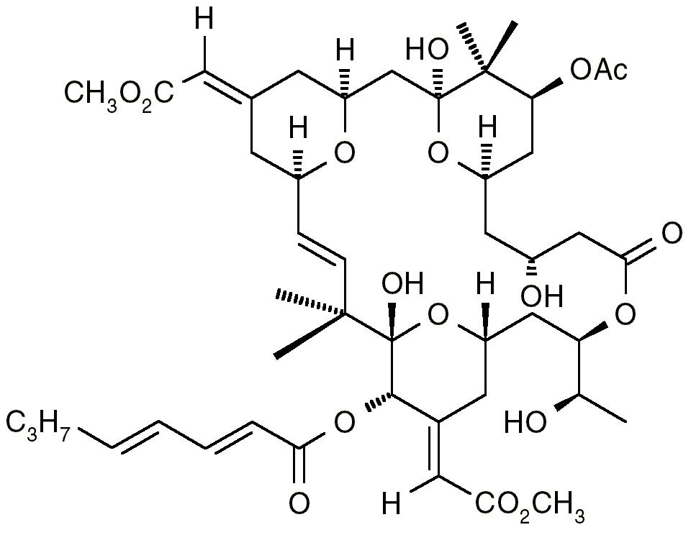
f) Which of these two molecules was found in the green-capped bottle? (And the answer does not lie in the obvious size-difference).
(Actually, neither of the two, but it's about the concept...). The one with the aromatic planes. You need co-planar aromatic planes to store the energy of an UV photon.

g) To escape from the earth’s gravity, a space shuttle must fly about 11 km/sec. The same holds for oxygen molecules, of course. Why haven’t all oxygen molecules escaped into space yet? Actually, about 0.1 mole of oxygen escapes from earth every day. How long will it take before we should start to worry about that? (Hint: solve the question about the spider first). Work this out on the back of a page and only give the answer here. If you get within a factor of thousand from the correct answers, I won’t look at the back of that page.
I have no idea, not within a factor of 10⁶, if this 0.1 mole per day is correct, but...
The surface area of the earth is about 510,072,000 km2 (see previous question, and remember that there is also air above the oceans, not only above the spiders). Planes fly at 10 km height already in very thin air. Lets gamble there is about as much air present above 10 km as there is missing below 10 km with missing defined as missing to make it 1 atmosphere pressure. That gives us 5*10⁹ km³ of air and that is 5*10¹⁸ m³. At 1 atmosphere, 1 m³ of air weighs about 1 kg (there is even a wikipedia page on this topic!) and that is about 60 moles of nitrogen. So we have 60*5*10¹⁸ moles of air available. Loosing 0.1 mole/day gives us ½*10*60*5*10¹⁸ days before half of the air is gone. So loosing air is probably not our biggest worry...

h) I think that most of us are smarter than birds, ants, rats, etc. That could be because we have bigger brains. So why are elephants and whales not smarter than we are? Brains are needed to store things, but very special connections are needed to do things we call logic.

i) Man evolved from monkeys and apes. So why are there still monkeys and apes left? Because something went wrong one day many, many years ago in just one monkey so that he became human. The other monkeys were lucky and stayed in the trees...

