SFB 2015-2016 Name

Take your time; three hours really is enough to finish everything. Read the questions well. If questions seem very simple, they probably are. Use common sense. Write legible; it is easy to oversee an error when the answer is written clearly and legibly. Keep the answers short (!) so think before you write. You can answer in Dutch, English, or Hochdeutsch. The amount of white space is all you get to answer. Don't use more space; shorter answers are always better (and take less time to grade). All questions are worth equally many points. If everybody writes clear and legible I promise that I will have it graded by Monday!

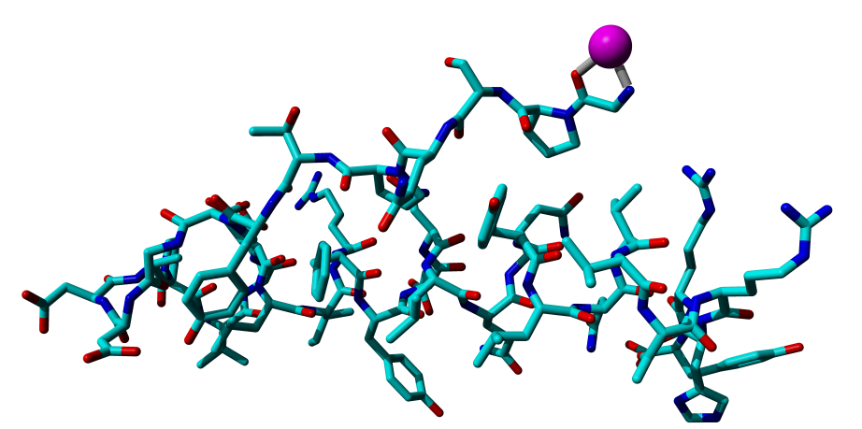
1) To the left you see a wireplot of the PDB file 1ppt.pdb.
This wireplot was made with WHAT IF so it should feel familiar…

a) What is the PDB?

b) Give me the first three (N-terminal) residues from the sequence of this protein.

c) Which atoms are binding the Zn²⁺ ion (purple sphere)?

d) What type of residues/atoms do you normally expect to find around a zinc ion that is bound to a protein?

e) So what do you think is possibly going on here? Why is this zinc sitting there? Give me a plausible hypothesis.

f) Now give me a radically different hypothesis for the question raised at e.

g) And give me yet one more radically different hypothesis for the question raised at e.

2) Write what you know about rotamers. (Define the term. How are they determined? How and for what applications can they be used? etcetera).

3) Write in your own words (formulas not needed; those come in a later question) how YASARA calculates the motions of all atoms in and around your molecule when you do a Molecular Dynamics (MD) simulation.

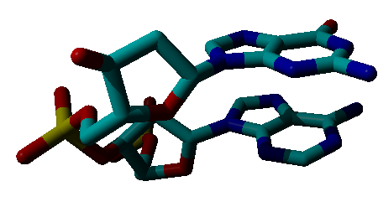
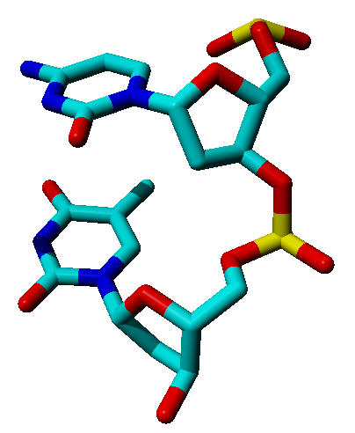
4)

a) What do you see in this figure? Indicate things you mention in the figure to avoid confusion.

b) I have observed this small fragment in a much larger molecule and extracted it using YASARA. That is why some parts are missing; they were lost while cutting this small fragment out of the complete molecule. Which parts are missing? Indicate things you mention in the figure to avoid confusion.

c) I observed that a big protein bound rather a-specifically to this small part using many arginines and lysines. Where did these residues bind?

d) Why were more arginines used than lysines for this a-specific binding?

e) I also observed two residues (Arg-17 and Asn-63) that bound in a highly specific way (in other words, these residues were binding in such a way that specificity was generated of the big protein for binding just to this small fragment). Please draw the side chains of arginine and asparagine in the molecular figure at the top of this question.

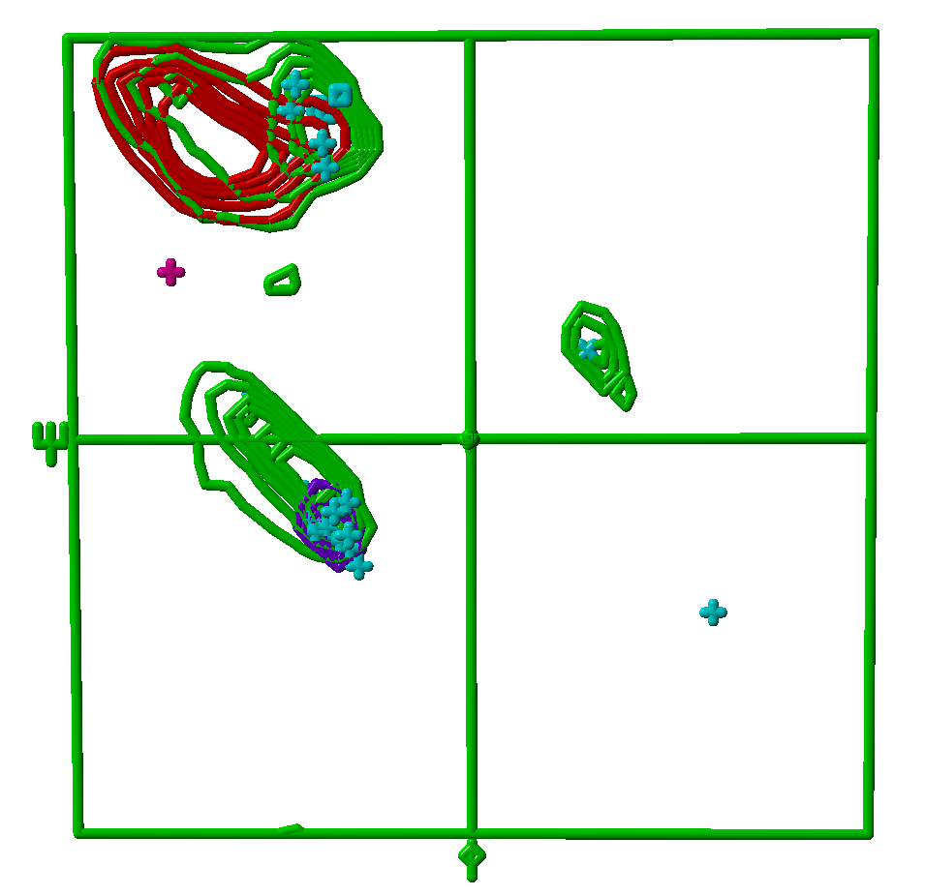
5) I guess I don't have to explain that this is a Ramachandran plot. As WHAT IF normally does, prolines are represented by squares, glycines by diagonal crosses, and all eighteen other residue types by orthogonal crosses. In this figure, the colours of the residues have merely an administrative function. Counting the crosses, you will easily realize that this is a very small protein (it functions only in a complex with another protein).

a) Give me your best guess of the protein's structure.

b) One of these residues has a role in the active site of the complex. Which one? And why do you say that?

c) One residue is indicated by a red/purple orthogonal cross. This is an asparagine or a glutamine. Give me your best guess which of the two it is.

d) This structure holds one proline. Find it, and tell me why you are not surprised it sits there. And tell me where else prolines can sit in Ramachandran plots. And explain why.

e) To complete sub-question a); tell me which secondary structure types you expect in which regions of the plot.

f) The region in the top right corner of the plot holds one residue only. It is, of course difficult to make a regular secondary structure element with just one residue. What is going on here?

6) Deep inside the protein nexistepas we find an Asp-112 that makes only one hydrogenbond. This aspartic acid, obviously, is involved in some kind of lyase function. I work together with the company GmbH.Inc and they want to get a very stable variant of nexistepas. GmbH.Inc is not interested at all in the lyase activity. Which mutations do you think I should suggest that they make?

a) First give me a series (at least three, but a few more is better) of mutation types that can stabilize nexistepas. I mean types of mutations like "mutate methionines into alanines because that normally works well because bladeebla etcetera" and not specific ones such as "mutate methionine 17 into alanine".

b) Can you also make one specific suggestion (for example Mutate Asp-112 into…..)? And explain your suggestion.

7) a) Why do most computational structure prediction methods (like transmembrane helix prediction, secondary structure prediction, antigenicity prediction etc) use a multiple sequence alignment rather than just one sequence as input? And illustrate your point with a small alignment (three sequences is enough to make your point).

b) The Chou and Fasman method is not a very good secondary structure predictor because it doesn't use secondary structure. Can you describe how Chou and Fasman designed their method?

c) How many residues are there in the average transmembrane helix? And why do most transmembrane helix prediction methods predict transmembrane helices of at most 20 amino acids long?

8) a) Many water molecules in the PDB should actually be ions, and vice versa. How come?

b) What does it mean "The resolution of this X-ray file is 1.4 Angstrom"? And is 1.4 Angstrom good or bad in terms of structure quality?

c) Per atom in the PDB you get some administrative parameters like its name and serial number, but also the X, Y, and Z coordinate, and occupancy and a B-factor. Explain what those are, occupancy and B-factor.

d) When we do structure validation, we react differently when we find an error in an X-ray structure than when we find an error in an NMR structure why?

e) In structure validation we use many force fields. Describe in less than 20 words what is a force field?

9) a) Formulas not needed, but allowed. Which terms/forces are used in the force field used by YASARA when you do a Molecular Dynamics (MD) simulation?

b) Can you mention a whole series of terms/forces (at least 5, but more would be better) that you think should also be used, but generally aren't?

c) Any idea why some of these terms/forces are missing? Are theoreticians in the MD field stupid or lazy, or is there a sound scientific justification for not including these terms/forces mentioned in 9b)?

d) Why is it a smaller problem than one would at first think that those terms/forces mentioned in 9b) are missing?

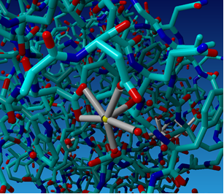
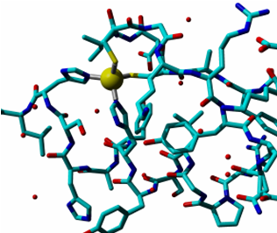
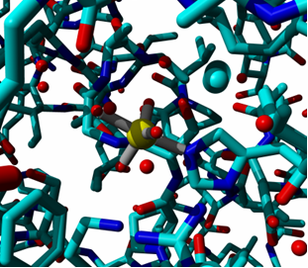
10) For a study on ions in proteins I started making pictures. Unfortunately, I lost the list that tells me which ion is in which picture. I don't want to make all pictures again. Can you help me and find out which yellow ball is Aluminium, which is Potassium, which is Vanadium, and which is Copper?

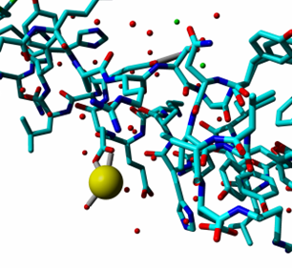

11) Describe in at most ten words per term what the term means:

Z-score

R-factor

MD

EM

BLAST

Homology Modelling

PDB

CSD

Salt Bridge

Bond angle

Torsion angle

NMR

MRS

Trajectory

SCOP, CATH, DALI

HSSP

DSSP

NOE

Crystal packing artefact

