1. 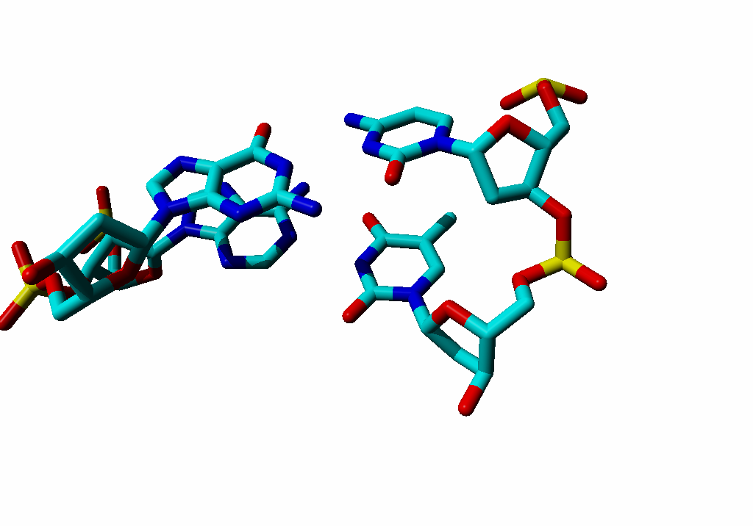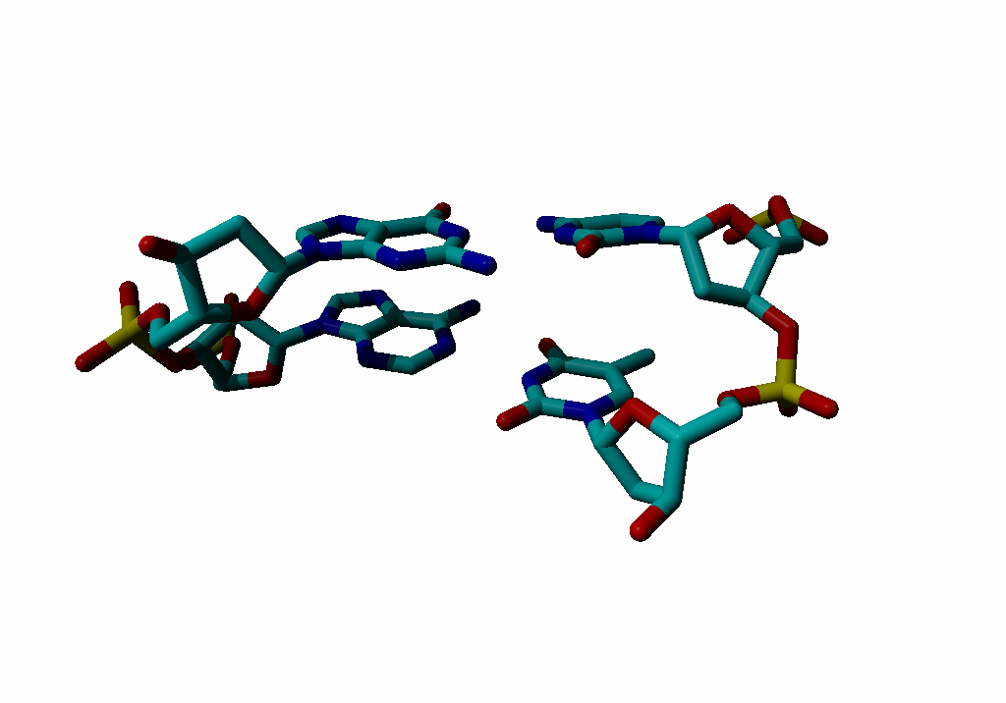Label the four bases with their name and one-letter code.
2. Is this DNA or RNA?
3. Put an asterix at atoms involved in ‘normal’ basepair hydrogen bonds.
4. Place near each base an arrow that incicates an atom that sticks into the major groove.
5. Sort by weight (lightest at the left): Asn, Ala, Arg, Gln, His, Pro

|  |  |  |  |  |  |
| --- | --- | --- | --- | --- | --- |
|  |  |  |  |  |  |

1. Sort by hydrophobicity (most hydrophobic left): Asn, Asp, Arg, Val, Phe, Ile

|  |  |  |  |  |  |
| --- | --- | --- | --- | --- | --- |
|  |  |  |  |  |  |

1. What is special about cysteine?
2. Wat is special about histidine?
3. On the next page you see a fully extended peptide. Write to the left of each amino acid its 1-letter code and its 3-letter code. To the right of each amino acid, write its secondary structure preference. (Although some atoms are hard to see because they point in or out of the paper, these are all ‘normal’ amino acids).

