1. 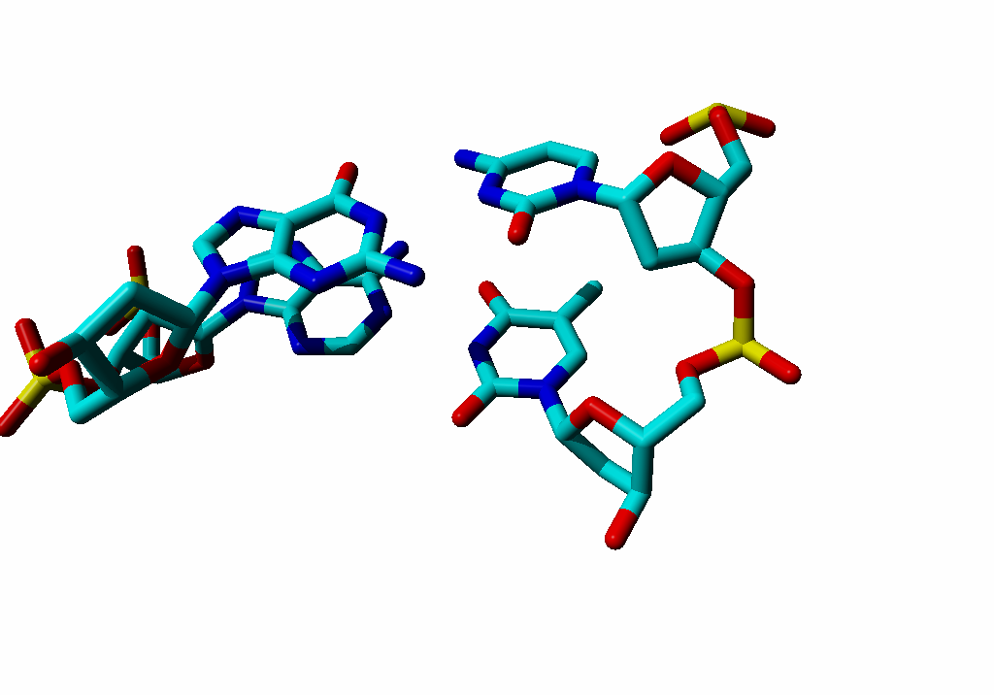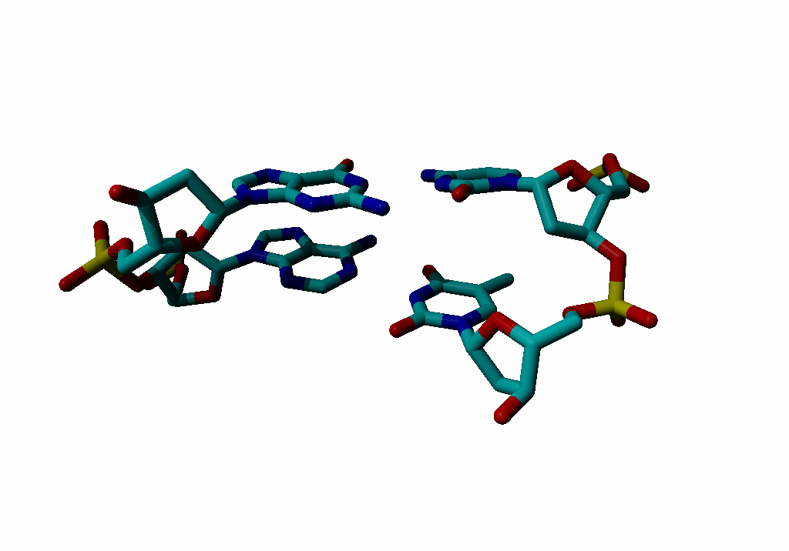Label the four bases with their name and one-letter code.

Left: G above A. Right C above T.

1. Is this DNA or RNA?
2. Put an asterix at atoms involved in ‘normal’ basepair hydrogen bonds.

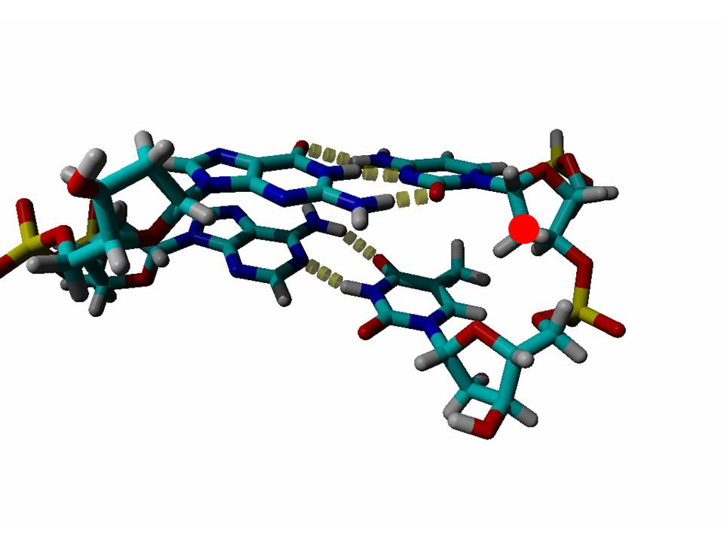At the left all 5 of them. At the right only the bottom O makes no basepair H-bonds:

Place near each base an arrow that incicates an atom that sticks into the major groove. Major groove is above/behind.

1. Sort by weight (lightest at the left): Asn, Ala, Arg, Gln, His, Pro

|  |  |  |  |  |  |
| --- | --- | --- | --- | --- | --- |
| ala | pro | asn | gln | His | Arg |

1. Sort by hydrophobicity (most hydrophobic left): Asn, Asp, Arg, Val, Phe, Ile

|  |  |  |  |  |  |
| --- | --- | --- | --- | --- | --- |
| Phe | Ile | Val | asn | asp | arg |

1. What is special about cysteine?

Can form bridges, reactive (can get oxidized easily), can bind metals like Cu, Zc, Cd etc, but not Na, Mg, Ca, etc.

1. Wat is special about histidine?

Can bind metals like Zn, Ni (think of his-tag), Cu, Cd, etc. Titrates around pH 6 and a bit, and thus easily copes with protons at the cytosolic pH which makes it a good active site residue.

1. 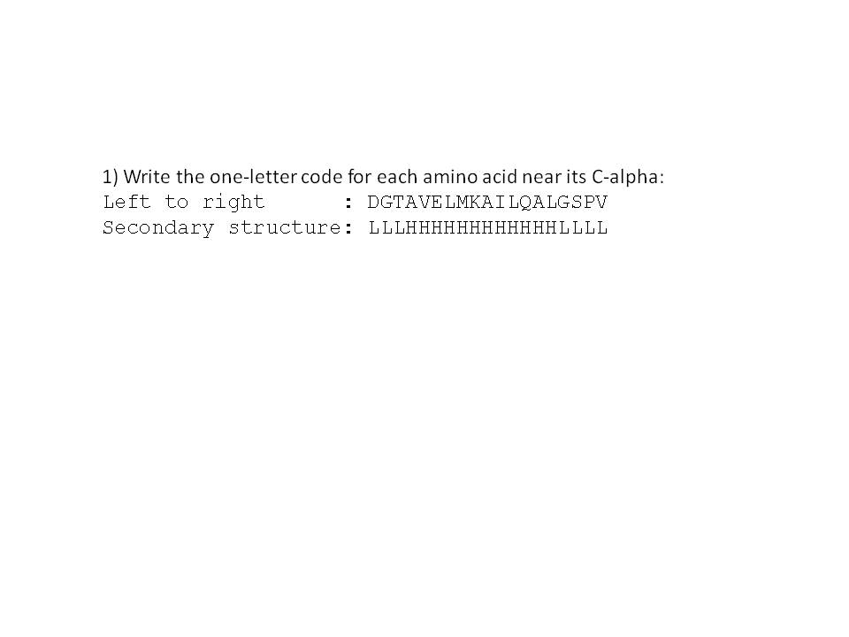On the next page you see a fully extended peptide. Write to the left of each amino acid its 1-letter code and its 3-letter code. To the right of each amino acid, write its secondary structure preference. (Although some atoms are hard to see because they point in or out of the paper, these are all ‘normal’ amino acids).

From N to C (bottom to top, in exam; below left to right) the sequence and predicted secondary structure (which was not part of the question, though) is:

Obviously the secondary structure prediction parameters are different when looked at one-by one:

AMELK -> H

PSDNG -> Loop

VITWYF -> S

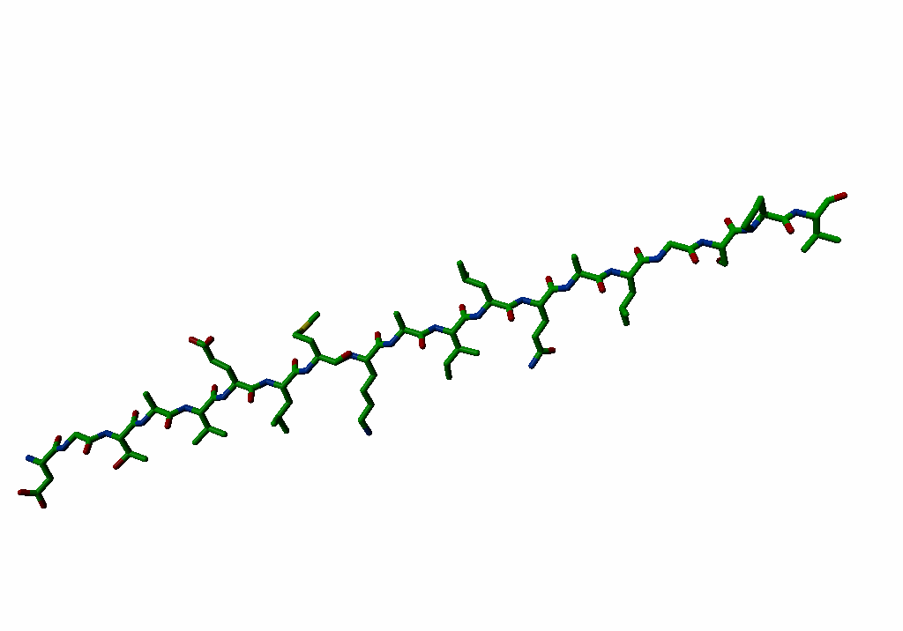The others are indifferent (but you may call Q who is present, and F who is not also good for helix)