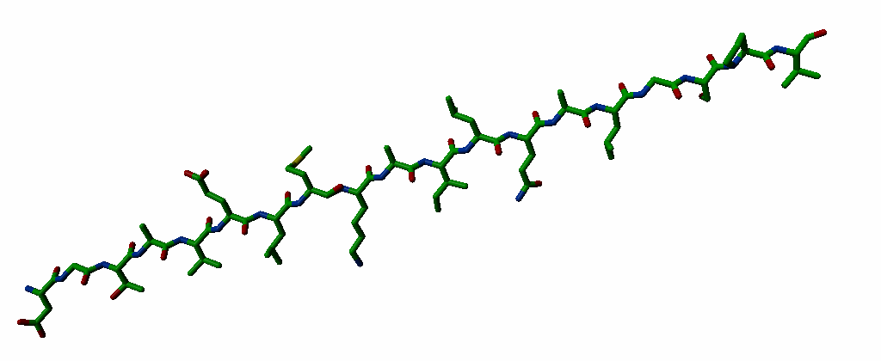
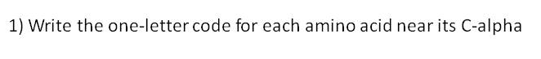
2) Predict the secondary structure of the above peptide:
3) Sort by weigth (lightest at the left): Val Gln Lys Ala Asn His
4) Which characteristics make Cysteine so special?

5) Why do we see Gly, Ser, and Pro often in β-turns?
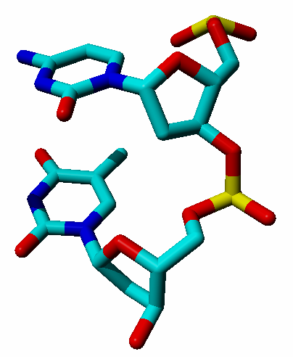
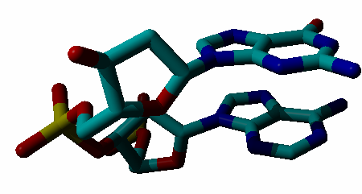

6) Label the four bases with their one letter code.
7) Is this DNA or RNA? And modify the C so that it becomes ‘the other type’ (so if it is RNA, make it DNA or vice versa).
8) Indicate on the A where the minor and major groove are located.
9) Label the hydrogen-bonded pairs of atoms with A, B, C, etc (so one donor and corresponding acceptor get the label A, one donor and corresponding acceptor get a B, etc).

