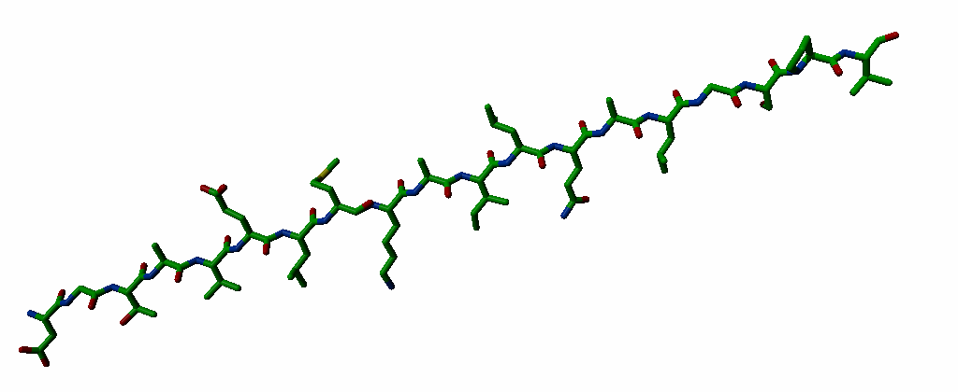
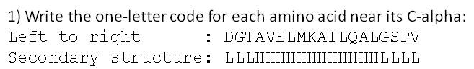
2) Predict the secondary structure of the above peptide: Loop-helix-loop as in 1.
3) Sort by weigth (lightest at the left): Val Gln Lys Ala Asn His: AVN(QK or KQ)H
4) Which characteristics make Cysteine so special?
Bridges, metal binding, can be oxidised / is reactive.
5) Why do we see Gly, Ser, and Pro often in β-turns? Gly flexible. Pro already fixed in correct conformation. Ser make H-bonds with own backbone.
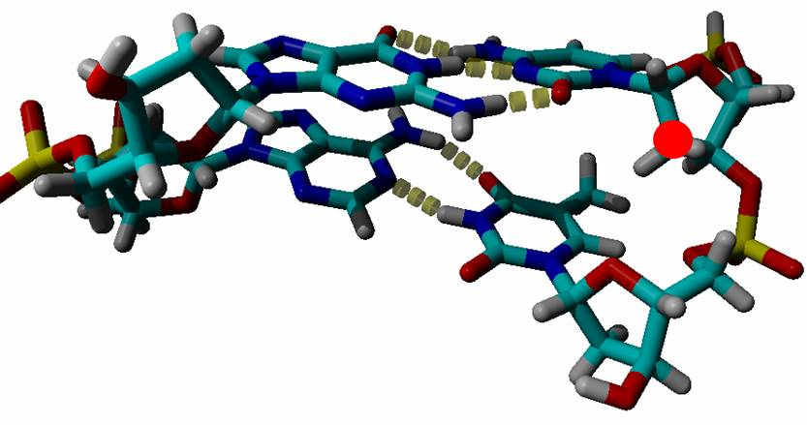

6) Label the four bases with their one letter code. Top left, clockwise:GCTA.
7) Is this DNA or RNA? And modify the C so that it becomes ‘the other type’. Add oxygen to the carbon with the red dot (I did not check the chirality so quickly...)
8) Indicate on the A where the minor and major groove are located. Major groove is above/behind.
9) Label the hydrogen-bonded pairs of atoms with A, B, C, etc (so one donor and corresponding acceptor get the label A, one donor and corresponding acceptor get a B, etc). H-bonds indicated, A-E simply from top to bottom.

