1) Which residues prefer helix, strand, turn:

H: AMELK (FQ)

S: VITWYF

T: PSDNG

2) What is the sequence (from N-terminus to C-terminus) of the peptide in this figure in three letter code? And what is it in one letter code? N-terminus is at the RIGHT side of the molecule. MHGSKDQILCA (and 3-letter code you can look up)
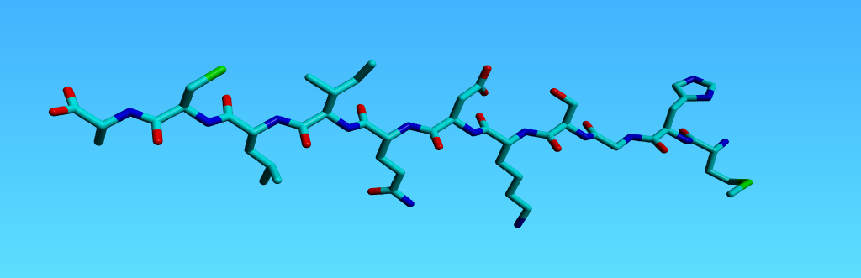
3) Cys, Pro, Trp, Met, His, Gly are more special than the other 14 amino acids. Why?
Which special things do you know about each of them?
Cys: Bridges; reactive, can bind metals
Pro: ring of N-Ca with side chain; therefore less flexible than the 19 others. And therefore has no H on backbone N.
Trp: Very hydrophobic; biggest amino acid and therefore hard to remove or insert by mutagenesis and by evolution, and thus the most conserved of all residues.
Met: Start codon, and thus often positively charged on its backbone N because of which it is found at the protein surface than its hydrophobicity does suggest.
His: Good at binding and releasing protons; titrates at around the pH of the cytosol. Is therefore a good active site residue. Good at binding metals (His tag binds Ni in/on column).
Gly: Doesn't have side chain (at least not more than a proton). The internal repulsions that therefore cannot take place make Gly extra flexible.

4) Sort by charge at pH 7.0: Asp, Ser, Asn, His, Lys
Asp is negative; Lys is the most positive; His is on average 10% of its time positive; Ser and Asn both are neutral (thus between Asp and His). But I would say that the dipoles in the O-C-NH2 group of Asn have larger partial charges than the O and H in Serine. But strictly formally speaking Ser and Asn both are neutral.

5) Below you find 10 bases (randomly cut from RNA and RNA) . Write to the right of each picture a D if this base was cut from DNA and an R when it came from RNA. Give the base name in one letter code (ACGTU). Put an asterix at each atom that is involved in Watson-Crick base-pairing. Write in the picture the character M at the side of the major groove.
Please think first and scribble on a scratch paper. With too many corrections etc., I can never grade things properly..

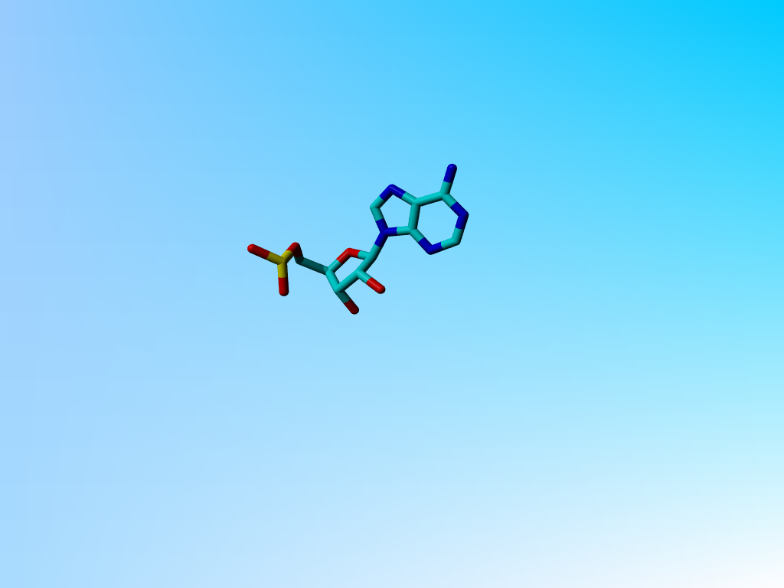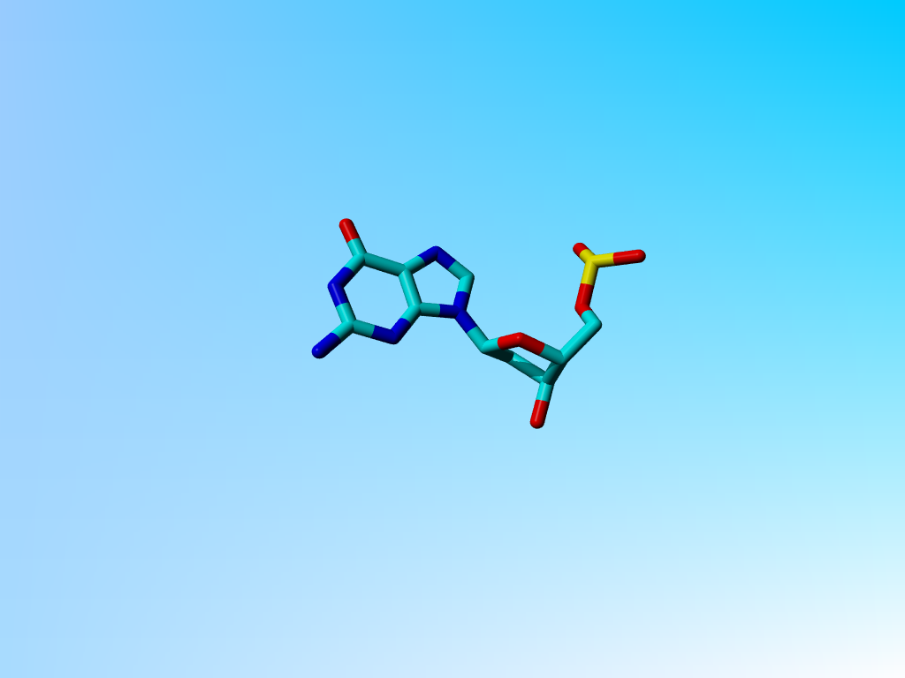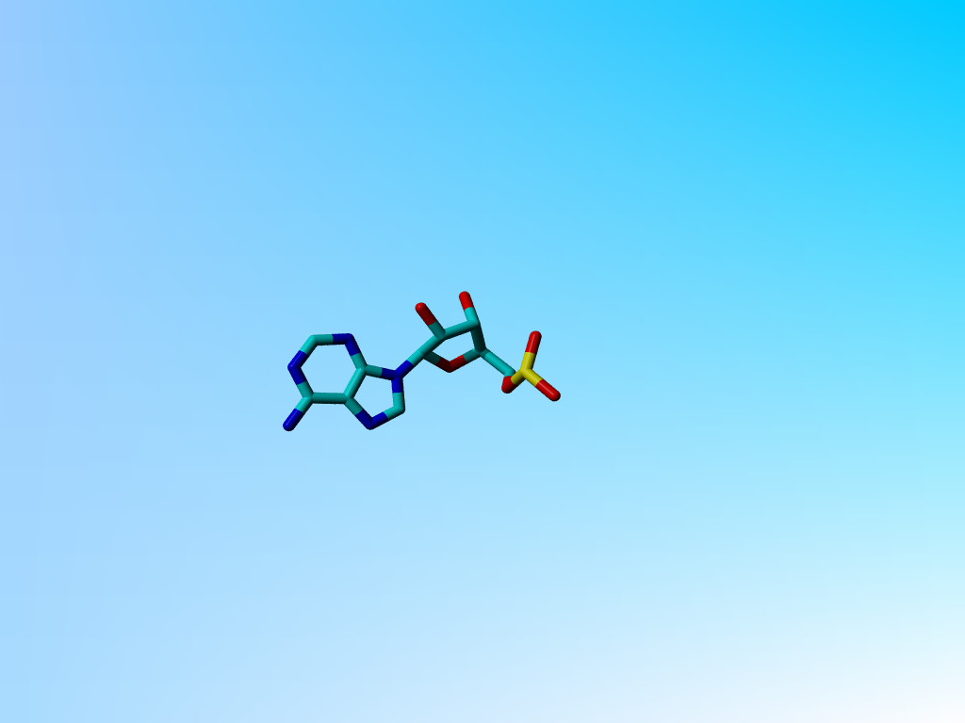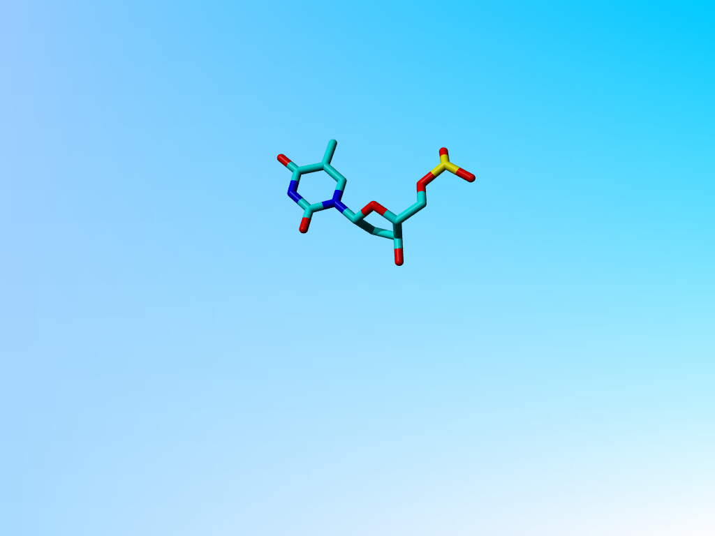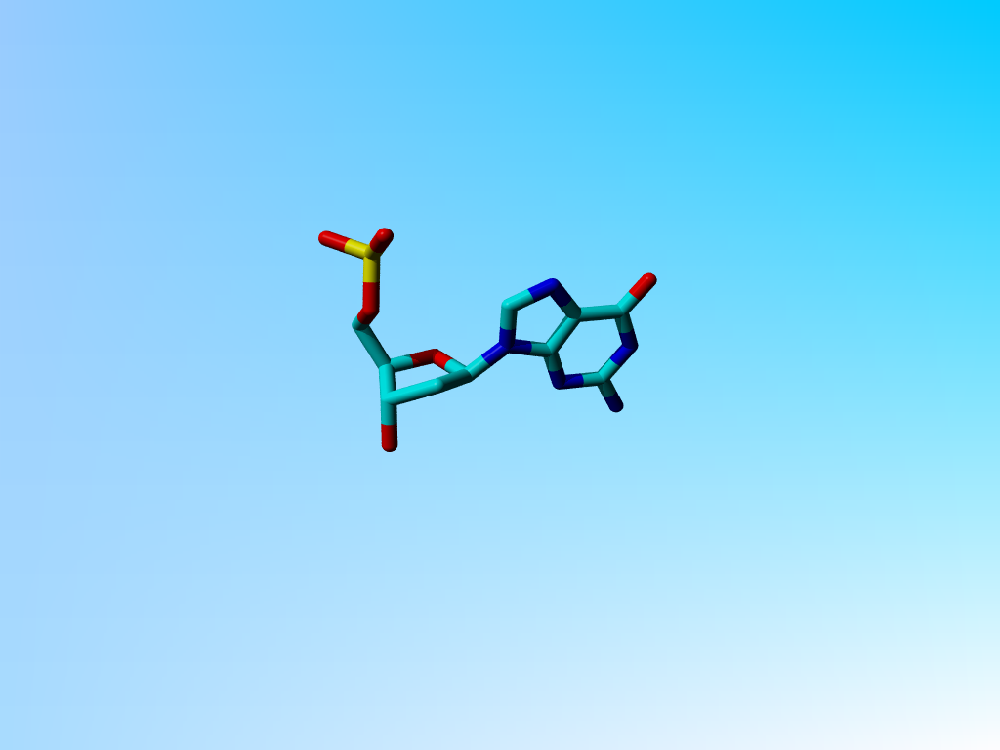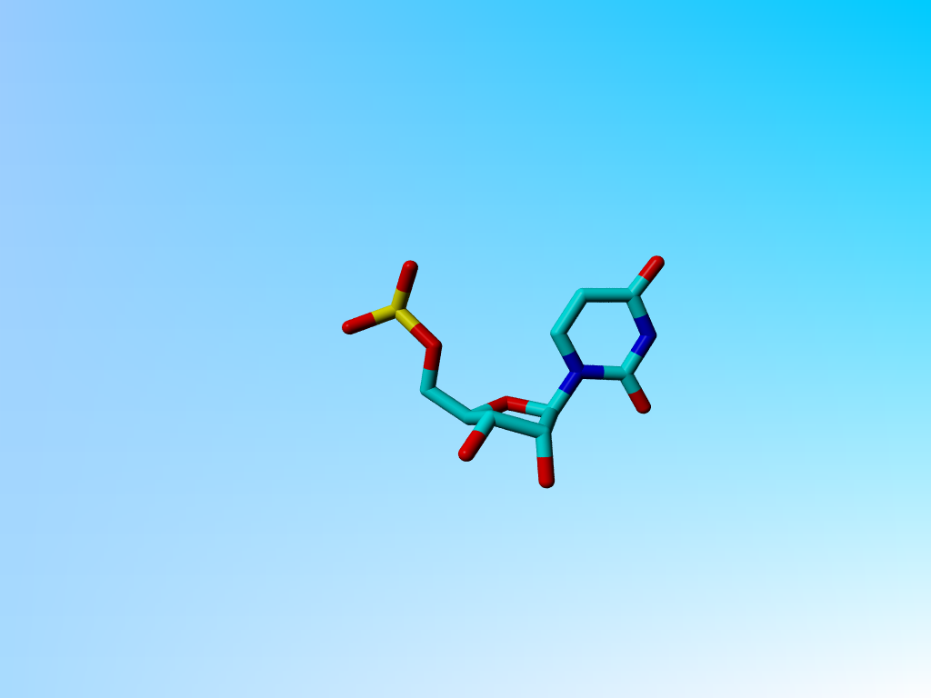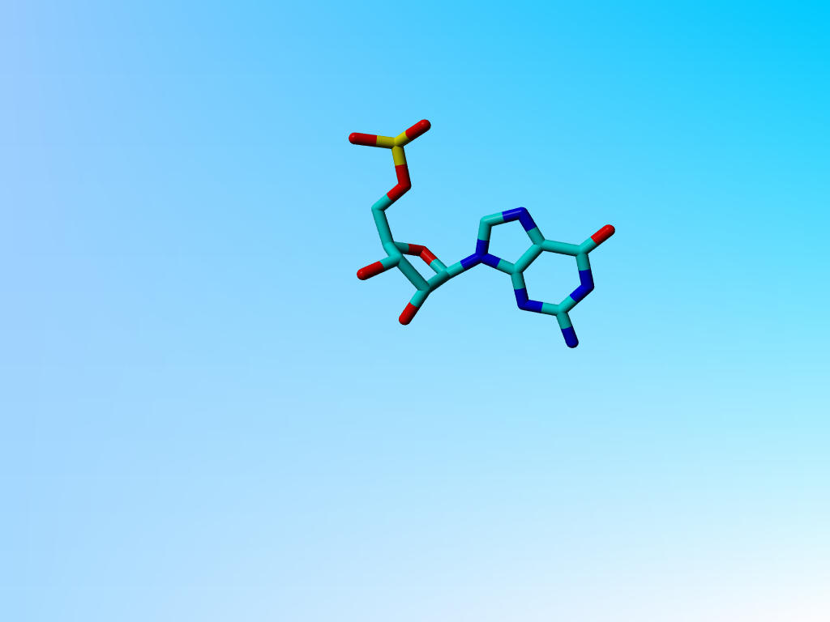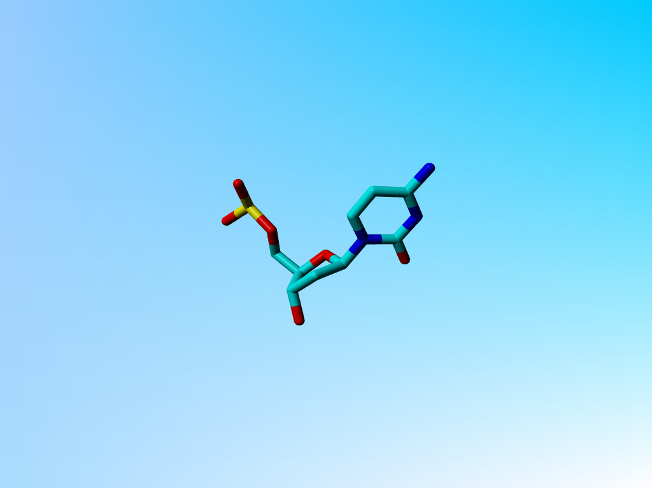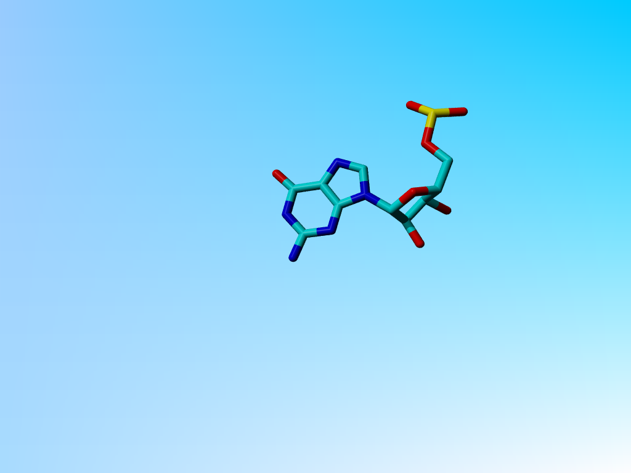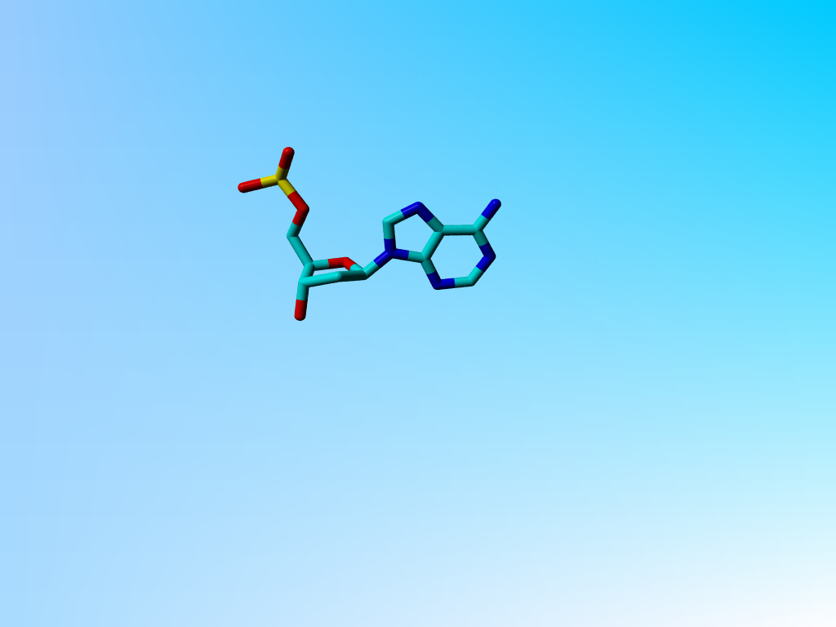
U H T L
R D

G H G H
D R

A H C H
R D

G H A L
D R

A H G H
D R

