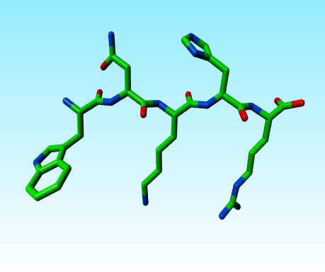
Question 1.
Write the sequence of this short peptide in three letter code:
TrpAsnLysHisArg
All five have one or more nitrogens in their side chain. These nitrogens have different pKa values. Sort them. Call the least basic nitrogen A and the most basic nitrogen E. Write A-E in the plot. In side chains with multiple nitrogens, you can safely assume that all nitrogens have the same pKa.
From A to E:
TrpAsnHisArgLys

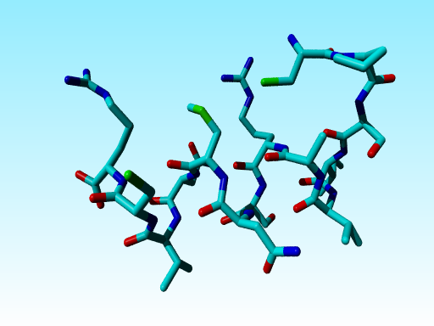
Question 2.
Find and circle the wrong amino acid in this figure.
You may assume that things that cannot be seen well are correct.
The Met in the middle misses one C in the side chain.
Question 3) One of the two helices below is a much better helix than the other. Find the three residue differences (write down which are the differences) and sort them by badness for the helix.

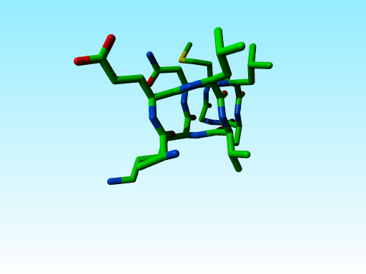
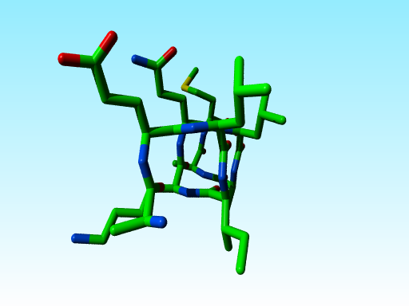

Differences are Gln versus Asn; Ile versus Val; and Ala versus Gly (obviously the right helix is better). As Ala is about the best residue for a helix and Gly the worst, the Gly->Ala difference is the most important, and how you sort the other two I don’t care.

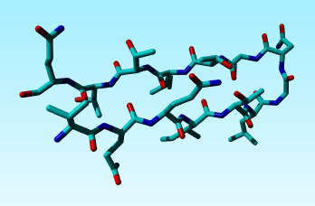
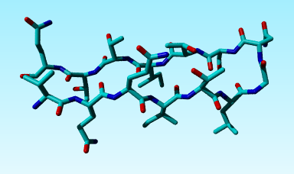
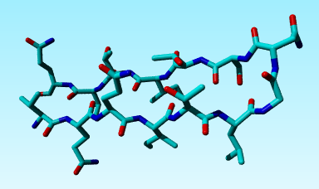
Question 4. These are three slightly different views of the same N-terminal β-hairpin from the VP2 protein in the common cold virus coat.
Write down the sequence of this peptide.
If you were the virus and wanted to optimize this β-hairpin, which four mutations would you make? And if you could only make one mutation which of those four would that be?
Sequence: VQQITLGNSTITTQ (I think).
Suggestion: VIQITIGNVTITVQ
Obviously, the bottom of this hairpin poits inward. So anything polar pointing down is fair game for mutation to something hydrophobic, and Ile is better than Leu. And the greatest improvement will be the Q->I at position 2 as that replaces a buried polar helix loving residue by a buried hydrophobic strand loving residue.

Question 5.
Sort by size (biggest first) Arg, His, Lys, Met, Gly. They were already sorted…
(You can count atoms in the pictures above…)

Question 6. Write their special characteristics to the right of the amino acids in the plot shown below.
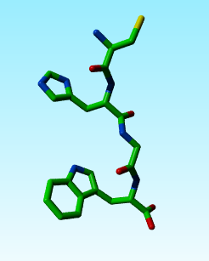
Cys, bridges, reactive, can bind metals
His, can be +/0/- (with 2, 1, o protons respectively). Good for active sites because of proton binding/releasing capability and its capability to bind metal atoms.
Gly very flexible because side chain is just H. Therefore good in turns, in flexible linkers, and at places where little space exists like helix-helix cross-over points.
Trp is the biggest, aromatic. Most conserved of all. Its N in the side chain is not very N-like (hardly polar because it is part of a big aromatic system.

