D.3.2. YASARA View coupling.

The coupling of the YASARA GmbH viewers has been achieved in a two-step process. First YASARA Model has been coupled to partner BIOP’s (BioProdict BV Nijmegen) 3DM database system. The experiences gained in this project were put to use in the incorporation of the free YASARA viewer, YASARA View, in the SSP. To ensure generality, the viewer demo was set-up to display output of partner ENANTIS’ (ENANTIS SRO, Brno) Hotspot Wizard. Some snapshots have been included as appendix to this deliverable to illustrate that the concept really works, and that the portal gives access to the data as promised.

At present the portal is technically ready, but the implemented concepts still must be put to use for protein engineers. Dr H Venselaar from the CMBI will visit partner FLUID (Fluid operations AG) in January to start working on the bioscientist friendliness aspects of the SSP. Dr Venselaar recently received her PhD (cum laude) on a topic intricately involved with translational research and bioscientist-computer interactions. Her major task in the second year will be the GUI.

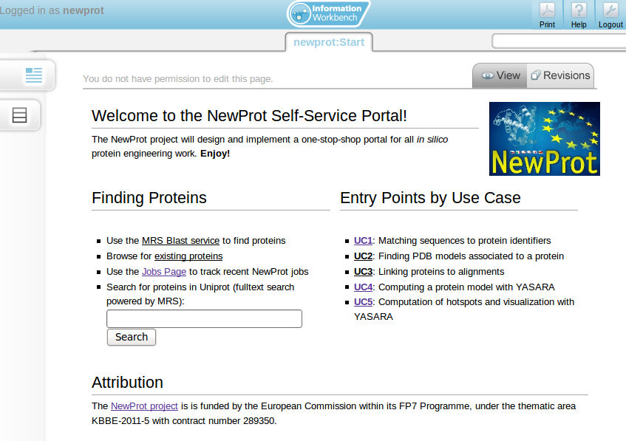Main page of the SSP portal. Five test cases have been worked out as described in deliverable D.1.1.

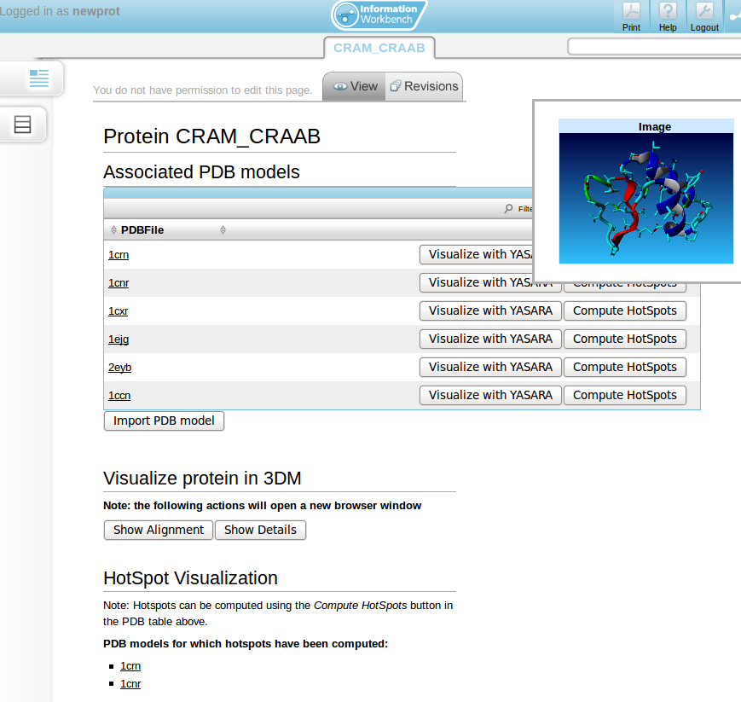

The SSP page for test case UC 4 illustrates that visualisation through YASARA indeed has been achieved.