

Deliverable 7.9 Kick-off meeting and web pages.

The NewProt project had a complicated start because the project negotiations took a long time and we had to start suddenly. Consequently, the kick-off meeting took place almost 2 months after the official start of the meeting. This has delayed everything a little bit, and due to the large number of involved companies (that tend to be a bit less flexible in terms of using extra manpower), we had not fully caught up yet at month 6, but at month 12 we are essentially on track.

So, the kick-off meeting took place late January 2012 in Nijmegen, and it consisted of a full week of scientific exchange, discussions about the consortium agreement, etc. The notes of the kick-off meeting are at the NewProt web site. Here all presentations and some minutes can be found too. The minutes of this kick-off meeting are added as the second half of this deliverable text.

At the kick-off meeting the web pages were presented. These pages, located at http://swift.cmbi.ru.nl/gv/newprot/, hold sections on the plan, the deliverables, the partners, etcetera. The web site also holds a restricted section (that can be entered using the username ‘user’ and password ‘newprot$’. The restricted section holds information about the meetings, copies of all deliverables, and other information that is not secret or sensitive, but that are not meant for everybody to be seen.

A few pages from the web site (screenshots made at month 12…) are attached to illustrate the extent of the web site.

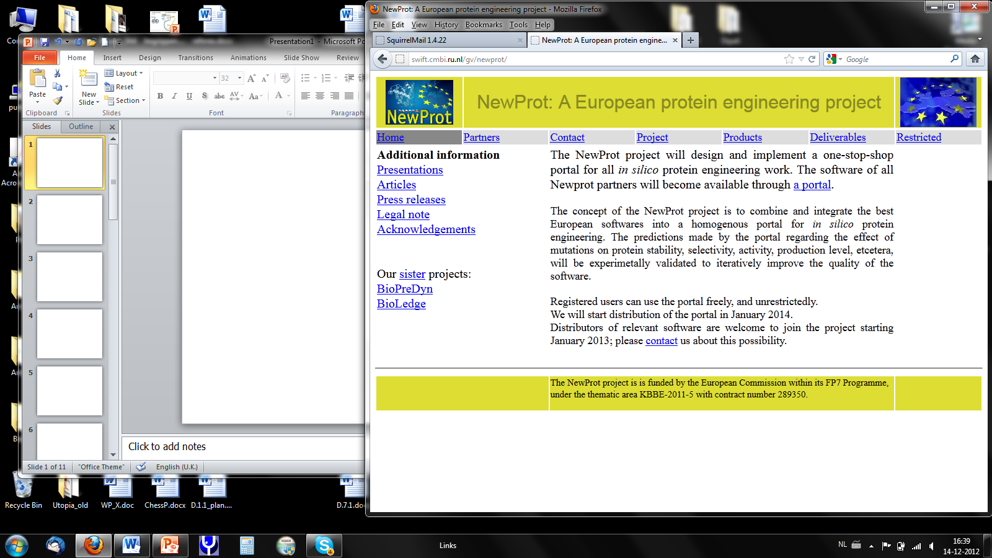

The entry page of the NewProt web pages.

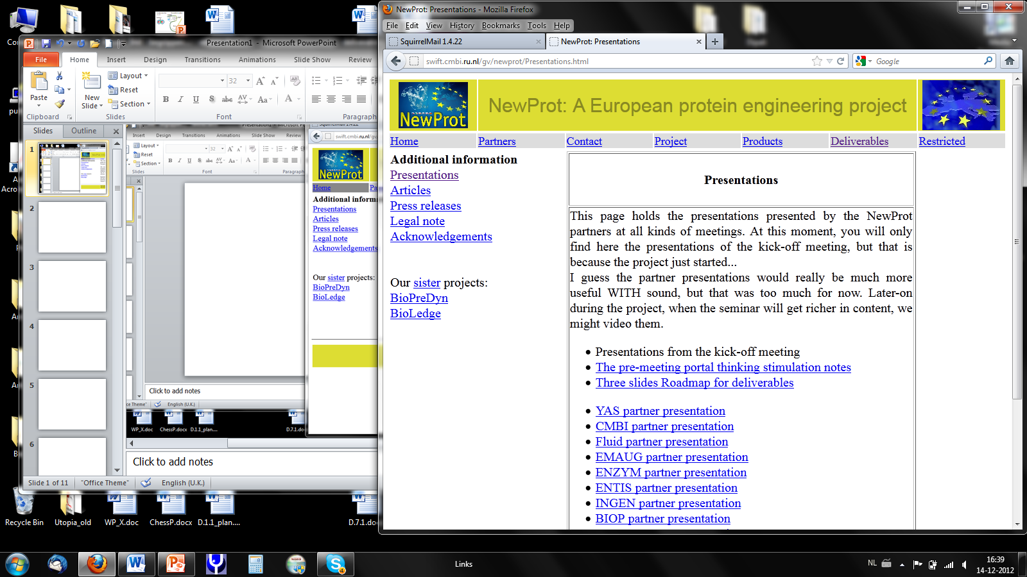

Under Deliverables we find, for example, partner presentation powerpoint presentations.

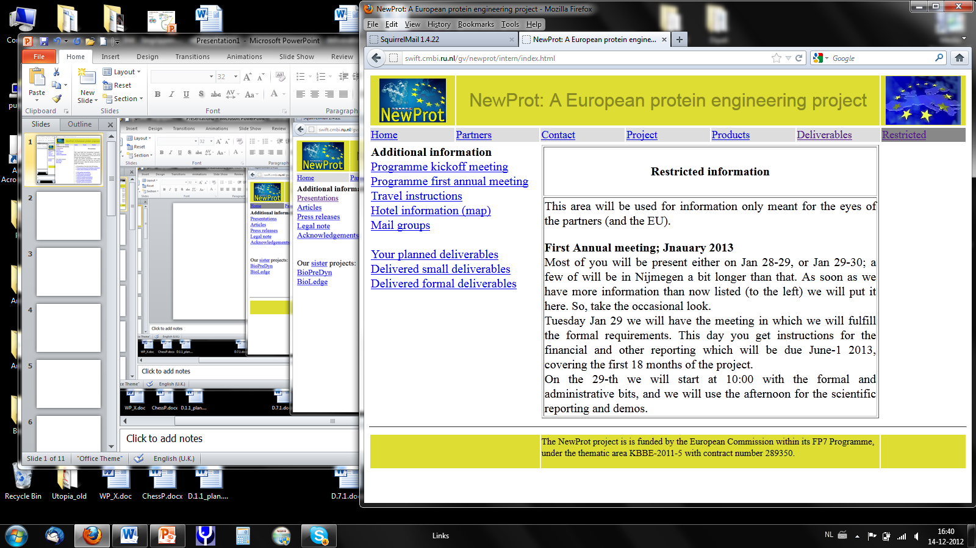

In the restricted section (username=user; password=newprot$) we find information not meant for the broader public like logistics of meetings, mailing list members, etc.

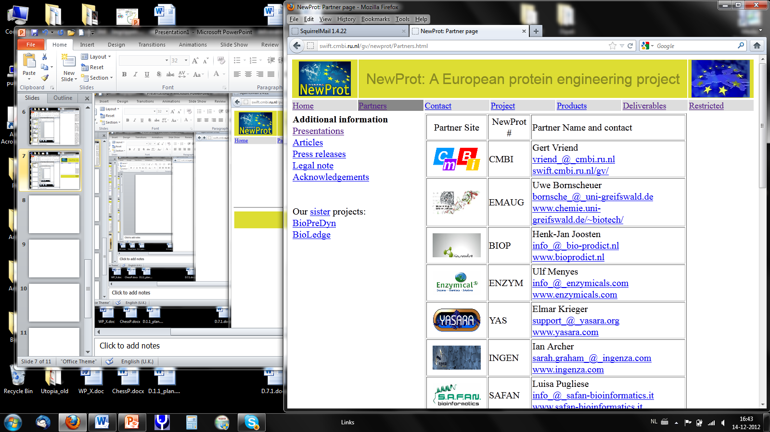

The tab Partners provides the minimal information needed to contact each of the partners.

The restricted area also holds a log of partner activities that are of a larger and multi-partner nature but that are not explicitly part of the DOW.

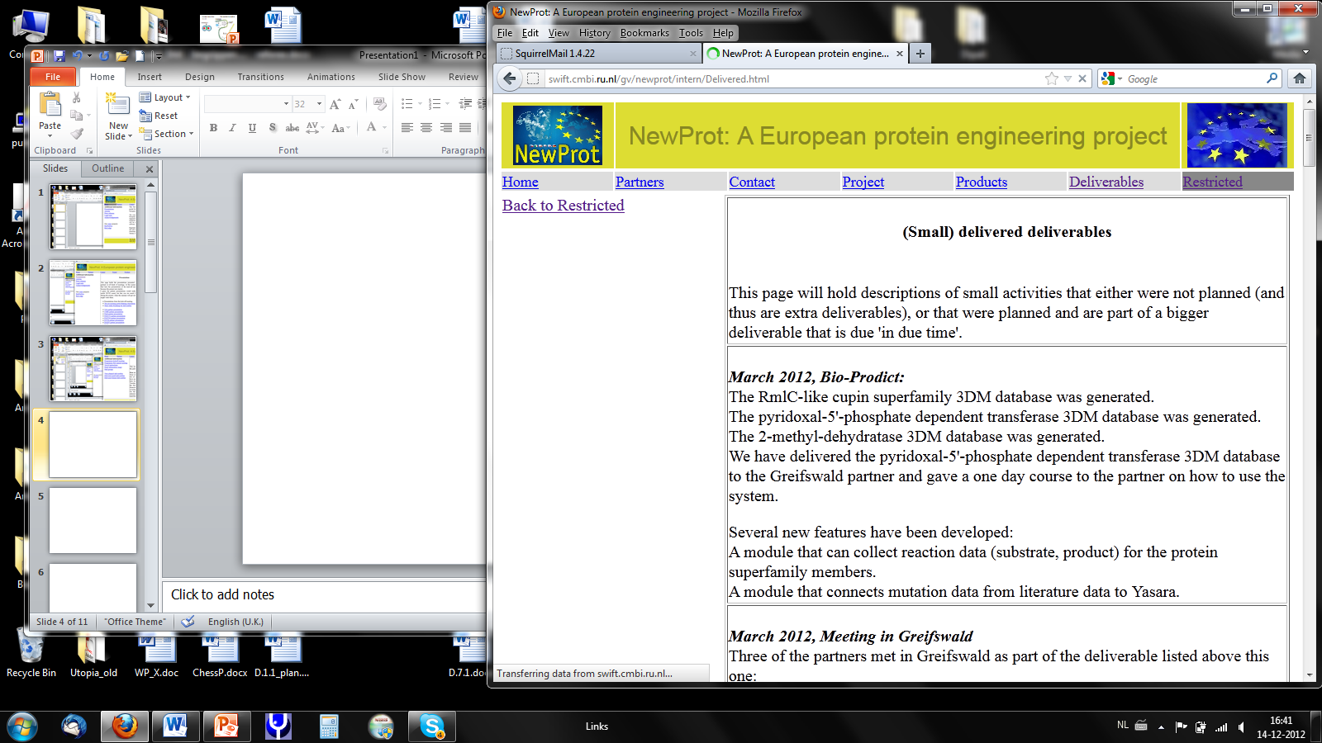

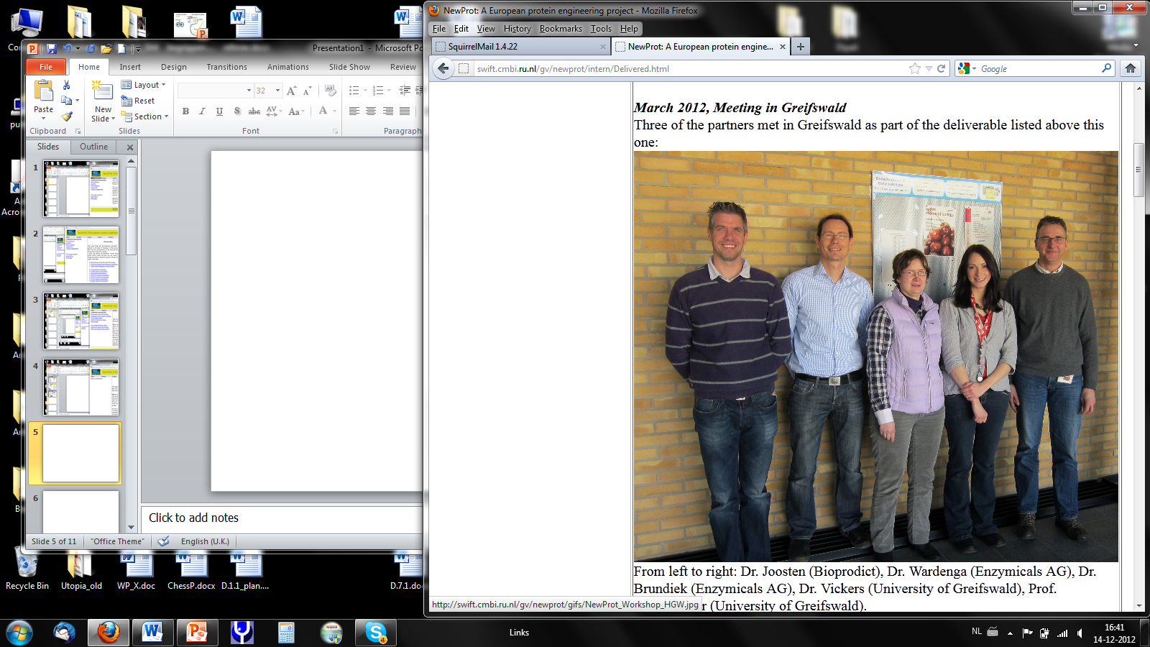

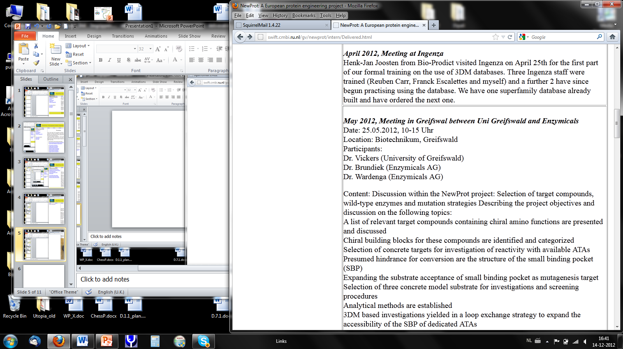

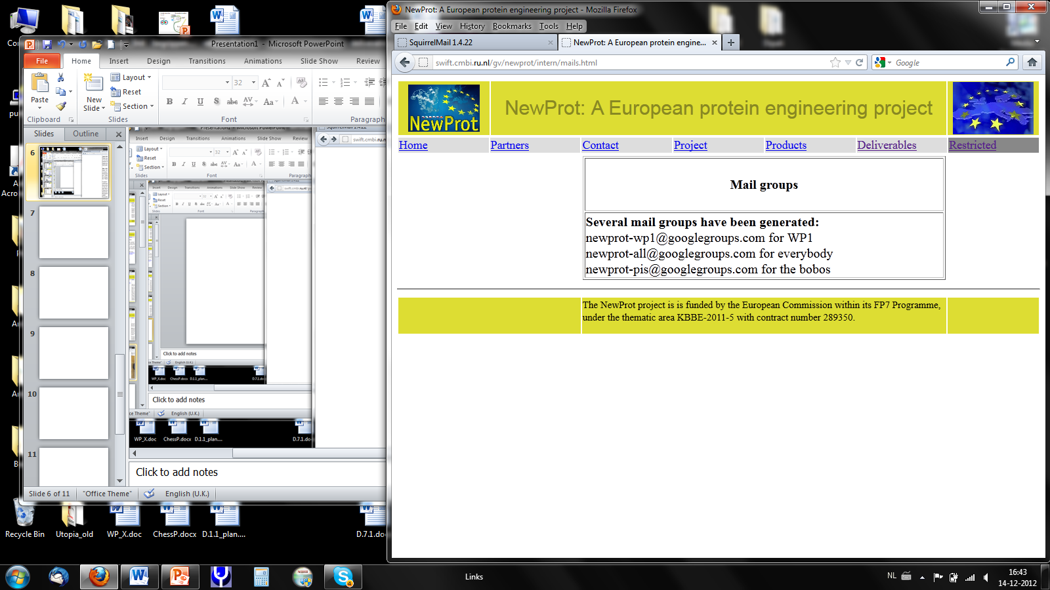

The restricted mail group page lists the mail groups presently active. Groups make so far are WP1 (encompassing everybody involved in the SSP); all which, as the name suggests includes everybody and should be used carefully; and pis which contains the names of all group leaders (PIs).

***Project acronym:* NEWPROT**

***Project full title:* "An interactive protein engineering portal with validated software and database facilities "**

***Grant agreement no.:* 289350**

***Grant agreement for:* Collaborative project. Small or medium-scale focused research project; targeted to SMEs.**

**THEME [KBBE.2011.3.6-01]**

**[Increasing the accessibility, usability and predictive capacities of bioinformatics tools for biotechnology applications]**

***Deliverable number:* D7.9**

***Deliverable title:* Kick-Off Meeting Minutes**

**Minutes NewProt Kickoff Meeting**

**January 25 2012**

Agenda:

1. G Vriend: Introduction to the NewProt project.

2. B v Kampen: Logistics

3. R Gerritsen, B v Kampen: Money matters

4. Start of partner profiles

G Vriend: CMBI

U Bornscheuer: EMAUG

C Vickers: EMAUG Experimental validation

R Wardenga: ENZYM

H-J Joosten: BIOP

I Archer: INGEN

E Krieger: YAS

P Haase: FLUID

S Nabuurs: LEAD

J Damborski: ENTIS

5. I Archer: Consortium agreement

6. P Haase: 'The portal'

7. G Vriend: Your To-Do-Lists

**Participants** **Kickoff Meeting NewProt January 25 2012**

|  |  |
| --- | --- |
| **Participant** | **Name** |
| ENZYM | Rainer Wardenga |
| ENTIS | Jiri Damborsky |
| ENTIS | Antonin Pavelka |
| INGEN | Ian Archer |
| FLUID | Peter Haase |
| FLUID | Michael Schmidt |
| FLUID | Andreas Schwarte |
| EMAUG | Uwe Bornscheuer |
| EMAUG | Clare Vickers |
| BIOP | Henk-Jan Joosten |
| BIOP | Remco Kuipers |
| LEAD | Sander Nabuurs |
| YAS | Elmar Krieger |
| YAS | Saulo H.P. de Oliveira |
| CMBI | Gert Vriend |
| CMBI | Barbara van Kampen |
| RUNMC | Rob Gerritsen |
| SAFAN | Luisa Pugliese* |

SAFAN had to cancel participation as Luisa was hospitalized with a broken leg.

1. Project coordinator Gert Vriend opens the meeting by welcoming all NewProt Partners.

A short description on how to work in EU projects follows with explanation of terms like ‘deliverables’. (See also the roadmap presentation).

- Deliverables are: Articles (mention the grant number in acknowledgements!), participation in meetings and workshops, meetings and workshops organized; patents; sales; Gert Vriend hopes to receive two-five ‘extra’ deliverables per team per year. Partners can add today’s presentation as an ‘extra’ deliverable. The website will list all deliverables you promised. Annual reports are 0.5-1.0 page A4 per team. Deliverable reports are 2-5 pages (richly illustrated). Note: All deliverables will be placed publicly accessible.

- About confidentiality: We have opted for the consortium form in which we voluntarily be amicable to each other. And that makes sense as we all benefit from the success of each individual; there are no secrets in this project. Everything is Background information, unless it is brought into the project either by plan (as written down in the accepted project plan), or as an extra.

- Uwe Bornscheuer coordinates experimental work, Gert Vriend coordinates computer work;

Decisions to be made soon:

- Communication: there will be a meeting like this every year. The minutes of the meeting and all software validation goes to the Advisory Board.

- Computers communication: suggests remote installation when easy, SOAP when needed.

- Portal technology

- Who validates what? (can be inverted into whose work can validate what?)

- Publication plan / authorship.

2. CMBI Office manager Barbara van Kampen informs the partners of how Project Management (PMO) is organized.

PMO will remind all partners of the deadlines for financial reporting, project reports, deliverables. All email communication concerning goes via Barbara van Kampen.

Barbara van Kampen will make the minutes of this meeting and will send a draft version to all partners within 10 calendar days.

3. Rob Gerritsen, RUMCN project finances, introduces himself and gives a short presentation on 3 major issues:

- Financial Reporting Periods. After 18, 36, 48 months the deadline for reporting is 60 days. We will have a trial after 16 months. This means all partners will send their financial information to Barbara van Kampen and Rob Gerritsen after 16 months. After 18 months partners can upload their information on the EU portal for NewProt (financial reports).

- Time registration (max 1650 hours, no working on holidays)

- VAT: EU does not accept VAT as eligible costs.

Rob Gerritsen will write an email including procedures. Rob Gerritsen, Barbara van Kampen and Gert Vriend will put all information on how to do these things on the NewProt website (http://www.newprot.eu/).

Advice A: Better start your administrative routine now than after 18 months!

Advice B: Keep all receipts concerning NewProt expenses and write ‘NewProt’ on them.

Rob Gerritsen will sort out if computers can be bought from the NewProt Budget.

4. Partner Profiles.

All partners will present their Profile by means of telling how they got into the NewProt Project, who are the people who are going to work on the NewProt project in your organization; what you hope to get out of NewProt, and what you want to bring in.

The profiles will be placed on the NewProt website.

5. Consortium Agreement.

The CA will be based on the latest Desca FP7 CA format (version 3). Ian Archer shows the options in several Articles.

Unanimous decisions are made on several Articles. Barbara van Kampen will hand the decisions to the TT officer of RUNMC to have a final version of the CA ready by the end of this week. Then the final version of the CA will be send to all partners and the CA can be signed.

6. The Portal.

Peter Haase gives a demonstration of all what is possible in the portal that will be built by the partners over the next coming years. Fluid, ENZYM, and CMBI have discussed for two days after the kick-off meeting on this portal. A detailed plan will be drafted over the next 4-6 weeks. We see no problems meeting portal-related deadlines.

7. Your to-do-list.

- Have the CA signed by your organization (within 60 days after the kick-off meeting

- Send the seminars’ ppt to Gert Vriend (all were obtained; Lead’s cannot be made open as there was IP in it; SAFAN’s will be placed on the portal shortly after Luisa is mobile again.

- The NewProt Logo is still open for discussion. Elmar made the only suggestion. This logo is now on the website…