NEWPROT PROJECT BILATERAL MEETING

Integration of HotSpotWizard to Information Workbench

March 20-21, 2012, Enantis, Brno, Czech Republic

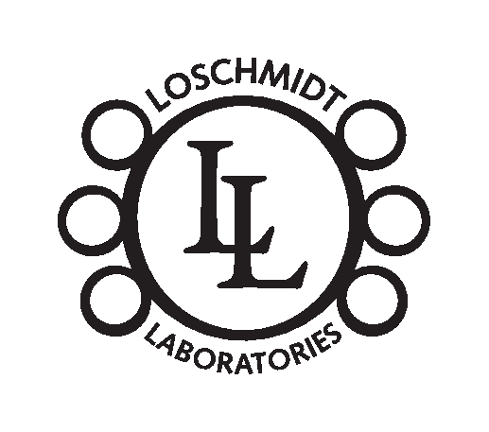



1) Participants

2) Minutes
The main objective of the meeting was to inform members of the development team of HotSpotWizard (HSW) about possibilities of fluidOps' Information Workbench (IWB) platform for Linked Data application development. The meeting was structured such that introductory presentations about IWB and HSW were followed by the practical examples of work with this platform and a discussion about integration options of HSW into the NewProt portal. The detailed schedule of the meeting was as follows:
  - 20.3. - morning session (participants: Andreas S., HSW team)
    - Loschmidt laboratories' presentations:
  - HSW 1.7 (Jaroslav B.) – introduction of the main idea of HSW, the target group and the workflow of the computation
  - HSW 2.0 (Jan Š.) – introduction of new planned features
  - MetaSNP (Jaroslav B.) – introduction of the main idea of this tool (prediction of the effect of amino acid substitution on protein function) which will be integrated to HSW 2.0
    - fluidOps' presentation:
- Introduction to Semantic web technologies (Linked Data, RDF, SPARQL) and FluidOps' Information Workbench platform
  - 20.3. - afternoon session (participants: Andreas S., Jaroslav B., Jan Š.)
- Detailed session and discussion about the Information Workbench – introduction to the Information Workbench SDK, development of sample applications
  - 21.3. - morning session (participants: Andreas S., Jaroslav B., Jan Š.)
    - Discussion about advantages & disadvantages of different of integration options of HSW into New-Prot portal.
    - Integration exampes of widgets in the Information Workbench – Jmol visualization and data manipulation with protein structure using the platform's widgets.
  - 21.3. - afternoon session (participants: Andreas S., HSW team)
    - Discussion about possibilities to use IWB platform in other Loschmidt Laboratories' projects.

3) Issues to be addressed

  - Computational capacity for HSW
HSW currently runs on local server. In case the number of users would increases significantly, our computational capacity may not be sufficient. Q: Is there any computational capacity dedicated to the partners of the NewProt project?

  - Licensing policy of the integrated tools
HSW uses many tools developed by third parties (usually universities). These tools usually do not allow commercial use. It should be kept in mind that HSW cannot be incorporated into commercial version without an agreement with the authors of these tools. Due to a high number of these tools, an agreement may be difficult to negotiate.

  - Integration of HSW to NewProt portal
Two possible options for the integration were considered:
Minimalist option – HSW will be running on local web server and will be visible through a HTML iframe. Visual style of other integrated applications of NewProt projects would be adopted.
Extended option – The UI of the HSW (including visualization) will be tightly integrated with the Information Workbench platform, i.e. visualization is achieved using the platform's widges.
- Advantages – Current version of HSW has an old-fashion way of working with form controls. This part should be updated in any case. IWB could provide a suitable platform.
- Disadvantages – Uncertainties regarding the enterprise license after finishing the EU project.

