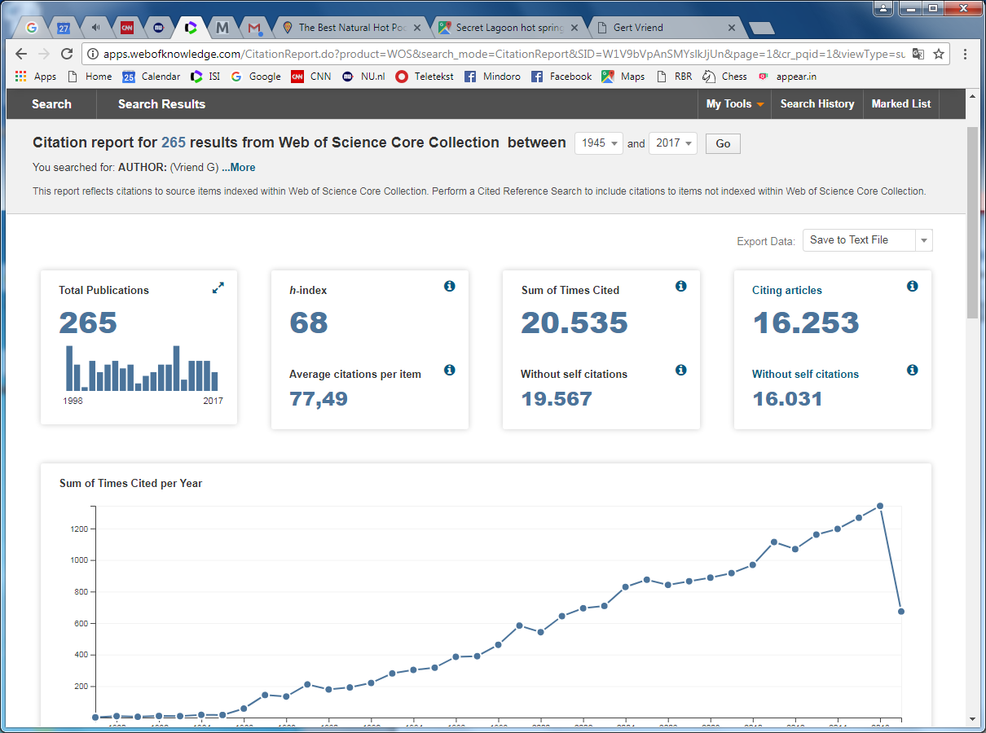Webofknowledge analysis of Gert Vriend. Vriend G, fortunately, is unique in the science world, so the Webofknowledge finds Gert’s articles flawlessly (albeit that about a dozen articles is missing in this list because Gert also occasionally publishes in mathematics, statistical thermodynamics, etc., journals.

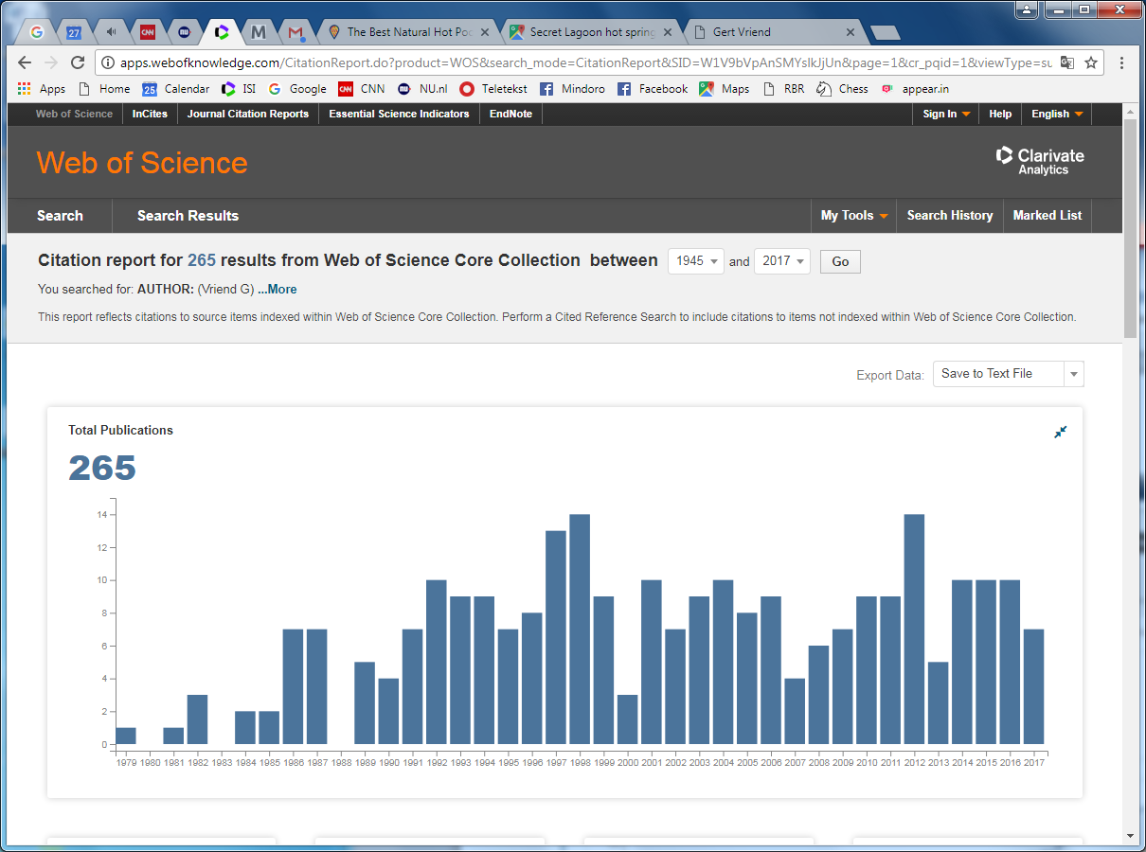Throughout the years Gert publishes about 8 articles per year. That seems not so much, but please remember that his group has always been very small (normally consisting of a post-doc, a programmer, and two PhD students).

In 1987 Gert spent 365 days to write the first 75000 lines of WHAT IF. In 1989 he moved to the EMBL, in 1999 he moved to the KUN (nowadays called RU), and in 2006 he moved to the Radboud medical centre (nowadays called Radboudumc). As you can see, moving is not good for science… (2013 was an externally induced little dip in his productivity…).

Google also thinks that Gert is the only Vriend in science, so if you go to: https://scholar.google.nl/citations?user=Uz6QsFoAAAAJ&hl=en

you will find all his articles and get the possibility to see the citation counts.