Bioinformatics A (MOL075) 2010-2011 Name
Take your time. Read the questions well. If questions seem very simple, they probably are. Use common sense. Write legible; it is easy to oversee an error when the answer is written clearly and legibly. Also first think and only then start writing when you know what you want to write; scratched-out answers, answers on the back of the next sheet, etcetera, all are a near guarantee that errors will be spotted. Keep the answers short (!); the amount of white space given with the question is indicative of number of words I expect you to need for the answer. However, if the reasoning makes sense, then you can still score many points for a wrong answer. You can answer in Dutch, English, or Hochdeutsch; if you don't know a word in one language, use the other one for just that word. If you don't understand something, you can ask the assistants, but in any case Gert will be back in the exam-room between 11:00 and 11:30. And finally, write your name on each answer sheet, especially also the separate amino acid test.

First, fill out the amino acid test.
1) What are the major strengths of the SwissProt database, and what is its major weakness?

2) What is the difference between a SNP and a mutation mentioned in OMIM?

3) Why are Gly, Asp, Asn and Ser more likely in beta turns?

4) Why is the capping effect by charged amino acids stronger at the N-terminal end than at the C-terminal end of a helix, and why?

5) What is meant with primary-, secondary-, tertiary- and quaternary structure of proteins?

6) Look at the sequence SSNPDLCLQACAKGGSGALEACIALCARLGSSN
How many cysteines do you count in it?
Which pairs of cysteines form bridges, and why?

7) Predict the secondary structure of VTVTGPVTVT. Explain your answer.

8) What is the role of water in protein folding? And how does this knowledge help you to make good sequence alignments for the transfer of information?

9) Sequence alignment is an important tool? Write down three scientifically relevant biological questions that can be answered with/using sequence alignment(s). (So, don't ask trivial things like "What does the alignment look of...").

10) Three of the following, aligned, sequences bind Calcium. Which three, and why do you think that?
SFTDALKNMKPYESSFTRIVN
SYTDALKNVKPYESSFTRVVN
SFTASLKNLKPYCSSFTRVIG
SFTDALKLIVPYESSFTDVIH
SWTAVLKLMVPYLSSFTDILR
11) You find the PROSITE motif N-{P}-[ST]-{G} in your newly discovered human brain protein. What do you do before you publish this finding?

12) Which cysteine can be oxidized in this protein fragment (an why?):
NHSADCLMLALLSAACLMIFALLLGTSKKT

13) In January 2010, I ran BLAST on a bacterial protease against SwissProt. I found only seven hits. In August 2010, I did the same run with the same protein, and I got the same seven hits, but this time the E-scores of these hits were worse than in January. Why?

14) Align CWEALALLAELALAAMKGSTPNGS with CWEALALLLEALMRGTTPNGG

15) Whatever I try, I can only bind the small organic molecule cystinofilus to one of the cysteines in SNGPAELCLKACLCALQALGGKS. Which one, and why?

16) What is the difference between MRS and BLAST? Which software do you use for what type of query?

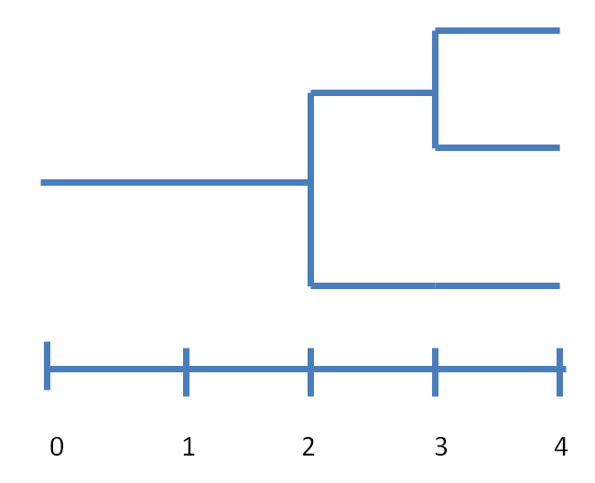
17) In the phylogenetic tree drawn to the right the horizontal axis indicates the number of identical residues that the sequences share. Design three sequences, called top, middle, and bottom, that, when aligned without gaps, lead to this tree.

18) At which end of a helix can you find prolines, and why?

19) Give the sequence of the "perfect" beta-hairpin (use about 14 amino acids, at least four of which should be charged)

20) GPNANGPALLEILSLIAEAAQALAGGNQDDEA Can be phosphorylated (at exactly one position!) by protein kinase L3. GGLEAAKLASSAASAAELLAGDNKKKW Can be phosphorylated by this enzyme too, but on which residue? Explain your answer.

21) If I want to stabilize a protein by mutating a limited number of residues. Can you think of some typical mutations that you would look at? And can you indicate if being accessible or buried has anything to do with the stabilization? And what is the role of the entropy of water in this story?

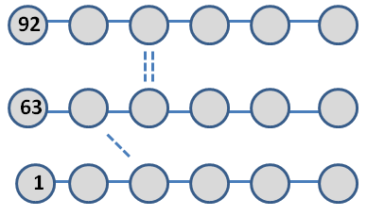
22) The picture to the right is a (very) schematic representation of a sheet that consists of 3 strands. Three residues have been numbered, and three hydrogen bonds have been indicated by dashed lines

a) Write the numbers of all residues in the gray circles.
b) Add the missing hydrogen bonds by drawing the (dashed) lines between the circles.
c) The three hydrogen bonds drawn are each between two atoms of course. Add those three hydrogen bonds to the list that I started for 1 hydrogen bond that was found 'elsewhere' in this molecule.
Donor residue Donor atom Acceptor residue Acceptor atom
19 | N | 43 | O

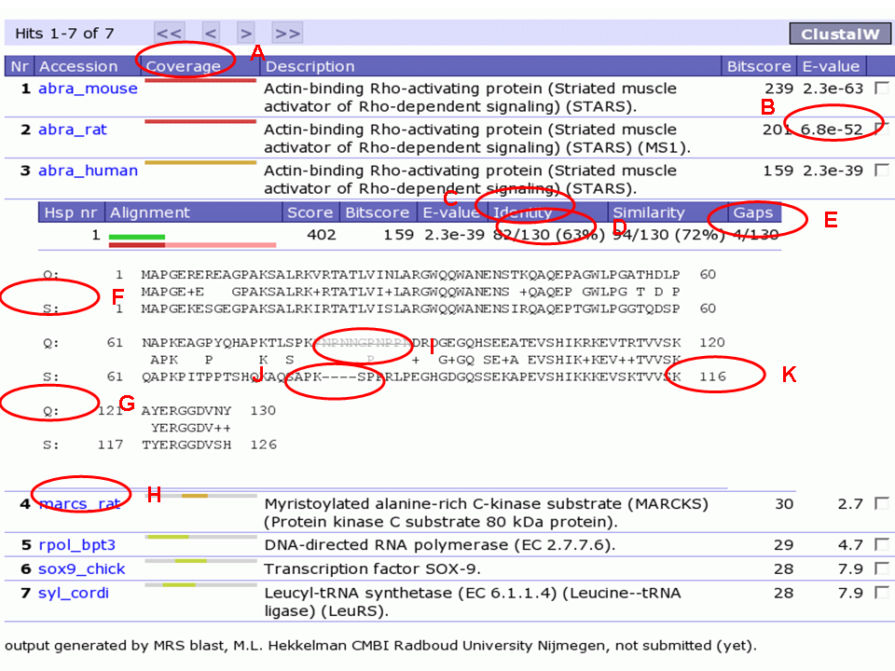
23) In the picture below I circled a series of elements. Explain their meaning.
A
B
C
D
E
F
G
H
I
J
K

