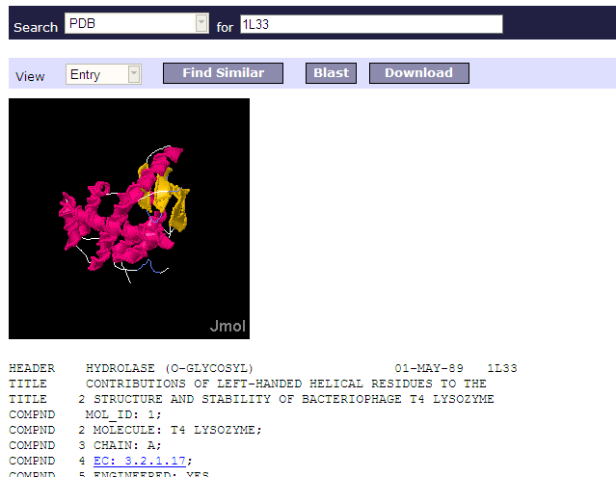

If you think you can use the structure download the pdb file and open it in a viewer.
The current strategy of saving PDB files from within MRS is:
- From the MRS hitlist select the PDB file you need.
- Make sure the “View” select box shows “Entry”
- Choose Download
- Save on PC with extension .pdb. (Not with extension .txt!!)
- This .pdb file will now be recognized by every structure displaying program, where it will show the 3D coordinates. The text of the file can also simply be read by Word/Wordpad etc.
To view the structure of a PDB file you can use one of the following viewers:
- Yasara (www.yasara.org)
- Swisspdb (http://www.expasy.ch/spdbv/
- Cn3d (http://www.ncbi.nlm.nih.gov/Structure/CN3D/cn3d.shtml)
- Protein explorer (http://www.proteinexplorer.org)

