Name:

Some hints:
Write clearly. If I have to spend time deciphering a question it is certain I find every error.
If questions are non-trivial, use the scratch paper first.
Short answers always are better than long answers; if you need more than 20 words for one answer, you are on the wrong track.
Don’t repeat the question in the answer. Be clear and exact. If the question would be “What kind of searches can be done with BLAST”. Neither “With BLAST you can search for proteins”, nor “Database searches” as an answer will give you many points, despite that both answers are strictly formally speaking correct.
You can answer in Dutch, English, or German. I don’t grade German exams too often, so if writing German, please write legible. If everybody writes clearly and keeps the answers concise, I will try to grade the exams before tomorrow.

1) What are the major strengths and the major weaknesses of the SwissProt database?

2) What is the difference between a SNP and a mutation mentioned in OMIM?

3) Why are Gly, Asp, Asn and Ser more likely in beta turns?

4) Why is Leucine not a good active site residue?

5) Why is Cysteine seldom seen at the surface of a protein?

6) Why is the capping effect by charged amino acids stronger at the N-terminal end than at the C-terminal end of a helix?

7) What is meant with primary-, secondary-, tertiary- and quaternary structure of proteins?

- What is a Dayhoff matrix?

9) Your newly discovered sequence contains the PROSITE pattern [S,T],{P},[K,R],{P} What should you do before you publish this pattern?
10) Draw a sequence of 14 amino acids of which the middle ten are perfectly helical and the outer two at both ends not.

- Align LEMAKRLPNSST with AAMEMILKAGTN

12) Align GPDWASDGTWAS with LANWLLKRSWAGTY

13) Predict the secondary and tertiary structure of GSITFEGPKVTANSIIIEGSSS

14) These two sequence predict to have the same secondary structure.
Which is that secondary structure?
And which of the two are you most certain of that it will actually adopt that
secondary structure in solution and why?
A) SGWEITVEGPKITFKV B) VKFKIENNTFKIEINT

15) Look at the sequence SSNPDLCLQACAKGGSGALEACIALCARLGSSN
How many cysteines do you count in it?
Which pairs of cysteines form bridges?

16) Give 4 examples of protein features that can be found in the feature section of a SwissProt file.

17) What do you think of the sequence VTVTGPVTVT?

18) What is more likely in a β-hairpin, a deletion of 2 residues or a deletion of 3 residues? And why?
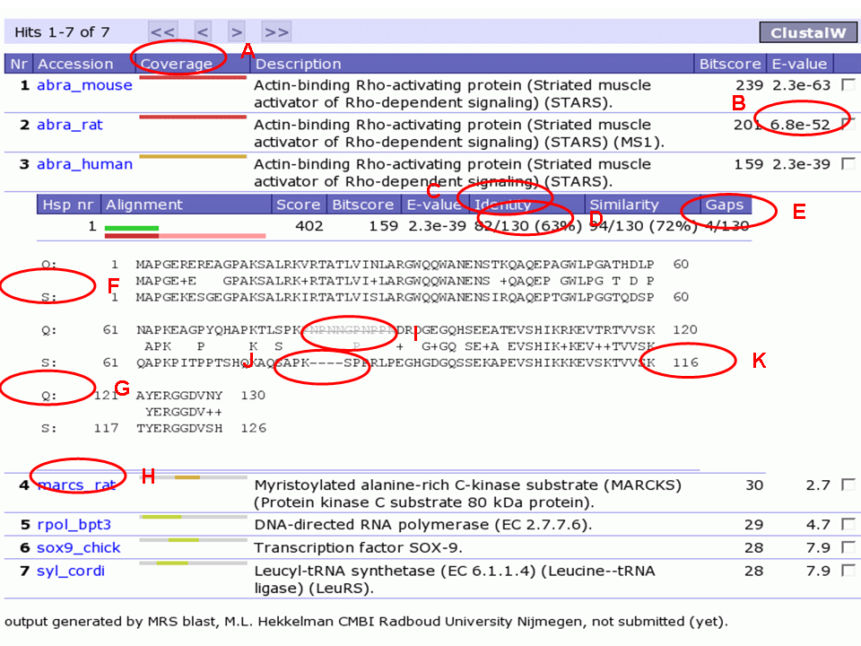
20) In the picture below I circled a series of elements. Explain the meaning of these circled elements A-K.
A
B
C
D
E
F
G
H
I
J
K

